

0994_APRIL2023

Queensland Government fifth annual progress report

**Royal Commission into Institutional Responses**

**to Child Sexual Abuse**

December 2022

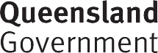

Copyright

This publication is protected by the *Copyright Act 1968.*

© State of Queensland 2023.

Licence

This work is licensed by the Department of the Premier and Cabinet under a Creative Commons Attribution (CC BY)

4.0 International licence. To view a copy of this licence, visit: https://creativecommons.org/licenses/by/4.0/

You are free to copy, communicate and adapt this publication, as long as you attribute appropriately, including:

* The name of the publication “Queensland Government fourth annual progress report Royal Commission into Institutional Responses to Child Sexual Abuse”
* A link to the work if you have sourced it online
* The copyright licence statement above
* Indicate if you have made changes to the work.

**Table of Contents**

Message from the Minister 2

Overview 4

Our approach to implementation 7

Five years of progress 9

Timeline of our achievements 11

Snapshot of 2022 progress 14

2022 Update from the Truth, Healing and Reconciliation Taskforce 15

Theme 1: Prevention and growing safer organisations 18

Our progress 19

Looking forward 29

Theme 2: Protecting children and young people 30

Our progress 31

Looking forward 47

Theme 3: Healing and support 48

Our progress 49

Looking forward 57

Information about support services 58

## Message from the Minister

It is my privilege to present the *Queensland Government’s fifth annual progress report: Royal Commission into Institutional Responses to Child Sexual Abuse* (Royal Commission).

The work of the Royal Commission was remarkable. It revealed the staggering extent of child sexual abuse in Australian institutions, helped us understand the lifelong impact of institutional child sexual abuse on people with lived experience and demanded we do better. I pay my respects to the many people with lived experience of institutional child sexual abuse who came forward to the Royal Commission to share their experiences and shape a safer Australia for children today.

When the Royal Commission concluded its five years of inquiry on 15 December 2017, it recommended that governments table annual progress reports in their parliaments for five consecutive years. This report is the Queensland Government’s fifth annual report, completing our commitment to reporting on Royal Commission implementation. As it is the final report, we have included a timeline of significant achievements over the past five years and an update of progress for each recommendation directed at the Queensland Government, either in full or in part.

The magnitude and ambition of the Royal Commission’s reforms called for a response from the Queensland Government of equal scale and drive. Over the past five years, Queensland Government departments and agencies have worked together, with non-government institutions, and with people with lived experience, support services and advocates to bring to life the recommendations of the Royal Commission. We have changed laws, invested in new programs and initiatives and improved how people who have experienced trauma are supported.

Thank you to the members of the Truth, Healing and Reconciliation Taskforce (the Taskforce), chaired by Robert (Bob) Atkinson AO APM, who have guided the Queensland Government on this journey with their invaluable advice, expertise and wisdom. The extension of the Taskforce to 31 December 2023 will allow it to continue its important work.

The conclusion of annual reporting does not mean that our work is over or that the Queensland Government will stop listening to the lessons of the Royal Commission. The Royal Commission has demonstrated that efforts to prevent child sexual abuse and grow child safe organisations; protect children and young people; and support the healing of people with lived experience, need to be steadfast.

The Royal Commission inspired a national conversation about institutional child sexual abuse, revealing its impact on people with lived experience and their right to justice and healing. The Queensland Government has played a part in continuing this conversation and our reforms over the past five years have made Queensland safer for children. It is my sincere hope that our efforts have also contributed to the healing of past wrongs.

**The Honourable Craig Crawford MP**

Minister for Child Safety

Minister for Seniors and Disability Services

# Overview

About the Royal Commission into Institutional Responses to Child Sexual Abuse

On 12 November 2012, then Prime Minister, the Honourable Julia Gillard MP, announced she would recommend to the Governor-General a royal commission to inquire into institutional child sexual abuse. On 11 January 2013, the Governor-General of the Commonwealth of Australia issued Letters Patent, appointing a six-member Royal Commission to inquire into institutional responses to child sexual abuse and related matters.

In the lead-up to the establishment of the Royal Commission into Institutional Responses to Child Sexual Abuse (Royal Commission), awareness of institutional child sexual abuse and calls for a national inquiry had grown within the broader community. These calls gained further momentum with the uncovering of a number of high-profile examples of failed institutional responses to child sexual abuse.

Originally scheduled to conclude by 31 December 2015, the Federal Government approved a two-year extension of the Royal Commission to 15 December 2017. In total, the Royal Commission ran for five years, holding its first sitting on 3 April 2013 and final sitting on 14 December 2017.

The process used by the Royal Commission included private sessions, public hearings and a research and policy program. Over 8,000 people with lived experience of institutional child sexual abuse came forward across Australia for a private session with a Royal Commissioner, with almost 1,600 private sessions held in Queensland.[1]

During its inquiry, the Royal Commission heard of the many and systemic failings of institutions to prevent, detect and appropriately respond to child sexual abuse. It made a total of 409 recommendations that together aim to fundamentally change how we see and respond to institutional child sexual abuse in Australia.

The Royal Commission’s 409 recommendations are contained in four reports:

1. final report - december 2017 - 189 recommendations over 17 volumes
2. criminal justice report - august 2017 - 85 recommendations
3. redress and civil litigation report - september 2017 - 99 recommendations
4. working with children checks report - july 2015 - 36 recommendations

1. Royal Commission into Institutional Responses to Child Sexual Abuse, Final Report: Volume 1, Our Inquiry, Sydney, 2017, pp 26-27.

The Royal Commission’s recommendations for reform are complex, inter-related and encompass all institutions engaging with children and young people. The Royal Commission has called for action from federal, state and territory governments, non-government institutions as well as the broader community. Many recommendations require long-term and sustained work to embed new practices, develop new laws and build new systems of regulation and oversight. Some recommendations aim for national approaches to prevent child sexual abuse and support the healing of people with lived experience of institutional child sexual abuse.

About the Queensland Government’s fifth annual progress report

The Royal Commission recommended (Final Report, recommendation 17.1) that the Federal Government and state and territory governments should each issue a formal response to its Final Report within six months of the Final Report’s tabling in the Australian Parliament.

In Queensland, the Honourable Annastacia Palaszczuk MP, Premier and then Minister for Trade tabled the *Queensland Government response to the Royal Commission into Institutional Responses to Child Sexual Abuse* in the Legislative Assembly on 15 June 2018.

The Royal Commission also recommended (Final Report, recommendation 17.2) that the Federal Government and state and territory governments should report on implementation through five consecutive annual reports tabled before their respective parliaments.

From 2018 to 2021, the Queensland Government has tabled four annual progress reports, detailing our progress in implementing Royal Commission recommendations each year.

This report is our fifth annual progress report, describing progress in 2022 to implement the Royal Commission’s recommendations. As it is the final annual report, we have also included a timeline of our significant achievements over the past five years and a recommendation-by-recommendation status update to describe progress since the Queensland Government response was released in 2018.

The Royal Commission’s recommendations are complex, ambitious and impact all institutions engaging with children and young people. While we have worked hard over the past five years to implement the Royal Commission’s vision, we have not yet completed every recommendation. We will continue working on these recommendations as well as existing policies, practices and initiatives that aim to prevent child sexual abuse, protect children and support people with lived experience into 2023 and beyond.

A number of Queensland Government departments have had a role in implementing the Royal Commission’s recommendations. This report reflects the work of:

* the Department of the Premier and Cabinet;
* Queensland Treasury;
* the Department of Justice and Attorney-General;
* the Department of Education;
* the Department of Child Safety, Seniors and Disability Services;
* Queensland Health;
* the Queensland Police Service;
* the Department of Youth Justice, Employment, Small Business and Training;
* the Department of Treaty, Aboriginal and Torres Strait Islander Partnerships, Communities and the Arts; and
* the Department of Housing.

The Queensland Government response and annual reports can be found here: https://[www.cyjma.qld.gov.au/about-us/reviews-inquiries/queensland-government-](http://www.cyjma.qld.gov.au/about-us/reviews-inquiries/queensland-government-) response-royal-commission-institutional-responses-child-sexual-abuse.

This report also describes our collaboration with the Federal Government and state and territory governments, including through the Community Services Ministers’ meeting, the Education Ministers’ meeting and the Ministers’ Redress Scheme Governance Board. Reports by the Federal Government on national projects can be found here: https://[www.childabuseroyalcommissionresponse.gov.au.](http://www.childabuseroyalcommissionresponse.gov.au/)

# Our approach to implementation

Of the 409 recommendations made by the Royal Commission, 317 are directed at the Queensland Government, either in full or in part.

In Queensland, we have organised these 317 recommendations across three key themes:

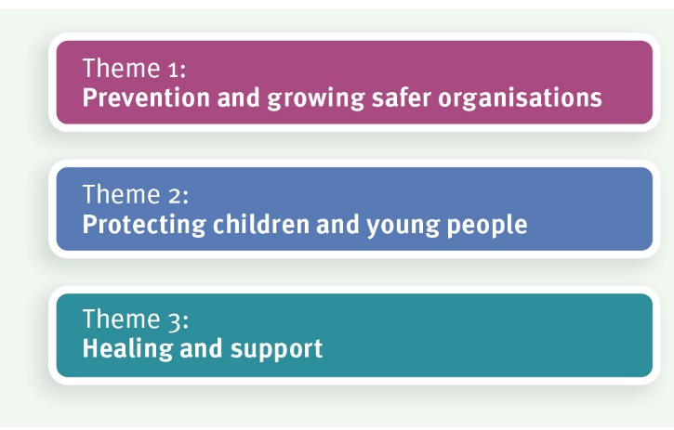

**Prevention and growing safer organisations** focuses on not repeating the mistakes of the past. This theme aims to grow child safe organisations and support the community to ensure they are better equipped to keep children and young people safe. This theme includes work on implementing the Royal Commission’s child safe standards and the development of national approaches including the *National Strategy to Prevent and Respond to Child Sexual Abuse 2021-2030* and *Safe and Supported: The National Framework for Protecting Australia’s Children 2021-2031*.

**Protecting children and young people** includes prevention and better detecting and responding to child sexual abuse when it occurs in institutions now. This includes improving reporting and information sharing and making our responses to children and young people sensitive to the trauma they have experienced. It also covers enhancements to the criminal justice system recommended by the Royal Commission to better protect children and young people.

**Healing and support** recognises the profound and ongoing impact of institutional child sexual abuse on people with lived experience. The focus of this theme is taking responsibility for the mistakes of the past with our participation in the National Redress Scheme, reforms to civil litigation and by improving how support services and the criminal justice system respond to people with lived experience. Under this theme of healing and support, we are also addressing the complexities of responding to children who engage in harmful sexual behaviours.

The diagram below shows how our themes align with the 317 Royal Commission recommendations directed at the Queensland Government, either in full or in part.

theme 1: prevention and growing safer organisations - Prevention - 38 final report recommendations aimed at creating safer institutions into the future through strengthening leadership, giving children a voice and giving institutions tools to hear their voices; building capacity and awareness; and monitoring our progress to implement recommendations. Includes national strategy, child safe standards, stronger prevention and response systems and monitor progress.
Theme 2: protecting children and young people - Protecting - 55 Final Report recommendations; 35 Working with Children Checks Report recommendations; and 56 Criminal Justice Report recommendations. Aimed at protecting children and young people engaged with institutions now. Includes initiatives to break down barriers to prevention, detection and response to child sexual abuse; and provision of trauma-informed care environments. Includes trauma-informed care and capacity building, reporting, improving data and reporting, enhancing criminal justice and legal responses, info sharing and suitability. 
Theme 3: healing and support - 17 Final Report recommendations; 28 Criminal Justice Report recommendations; and 88 Redress and Civil Litigation Report recommendations. Aimed at improving capacity to support children and adults who have experienced child sexual abuse; and children with harmful sexual behaviours; as well as protecting records into the future to improve institutional accountability. Includes trauma-informed justice responses; redressing past wrongs; protecting records, responses for children with harmful sexual behaviours and improving service responses. This summary is inclusive of recommendations directed towards Queensland Government only (excludes recommendations directed only at Federal Government, other states/territories and non-government institutions) 

# Five years of progress

When the Premier tabled our Queensland Government response in the Legislative Assembly on 15 June 2018, our position on the 317 recommendations directed at the Queensland Government, either in full or in part was:

Theme 1: prevention and growing safer organisations; 1 noted, 5 accept, 5 for further consideration, 27 accept in-principle.
Theme 2: Protecting children and young people; 8 noted, 22 accept, 58 for further consideration, 58 accept in-principle.
Theme 3: Healing and support; 5 noted, 61 accept, 26 for further consideration, 41 accept in-principle

Five years later, our position on the 317 recommendations directed at the Queensland Government, either in full or in part is:

Theme 1: Prevention and growing safer organisations; 1 noted, 5 accept, 32 accept in principle.
Theme 2: Protecting children and young people; 4 noted, 37 accept, 1 for further consideration, 104 accept in principle.
Theme 3: healing and support; 4 noted, 75 accept, 2 not accepted, 52 accept in principle.

# Timeline of our achievements

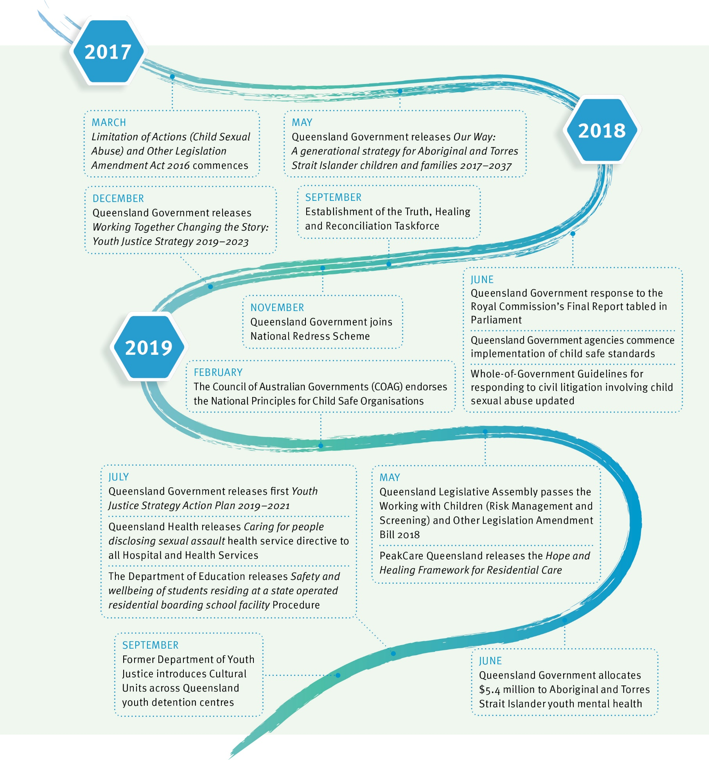

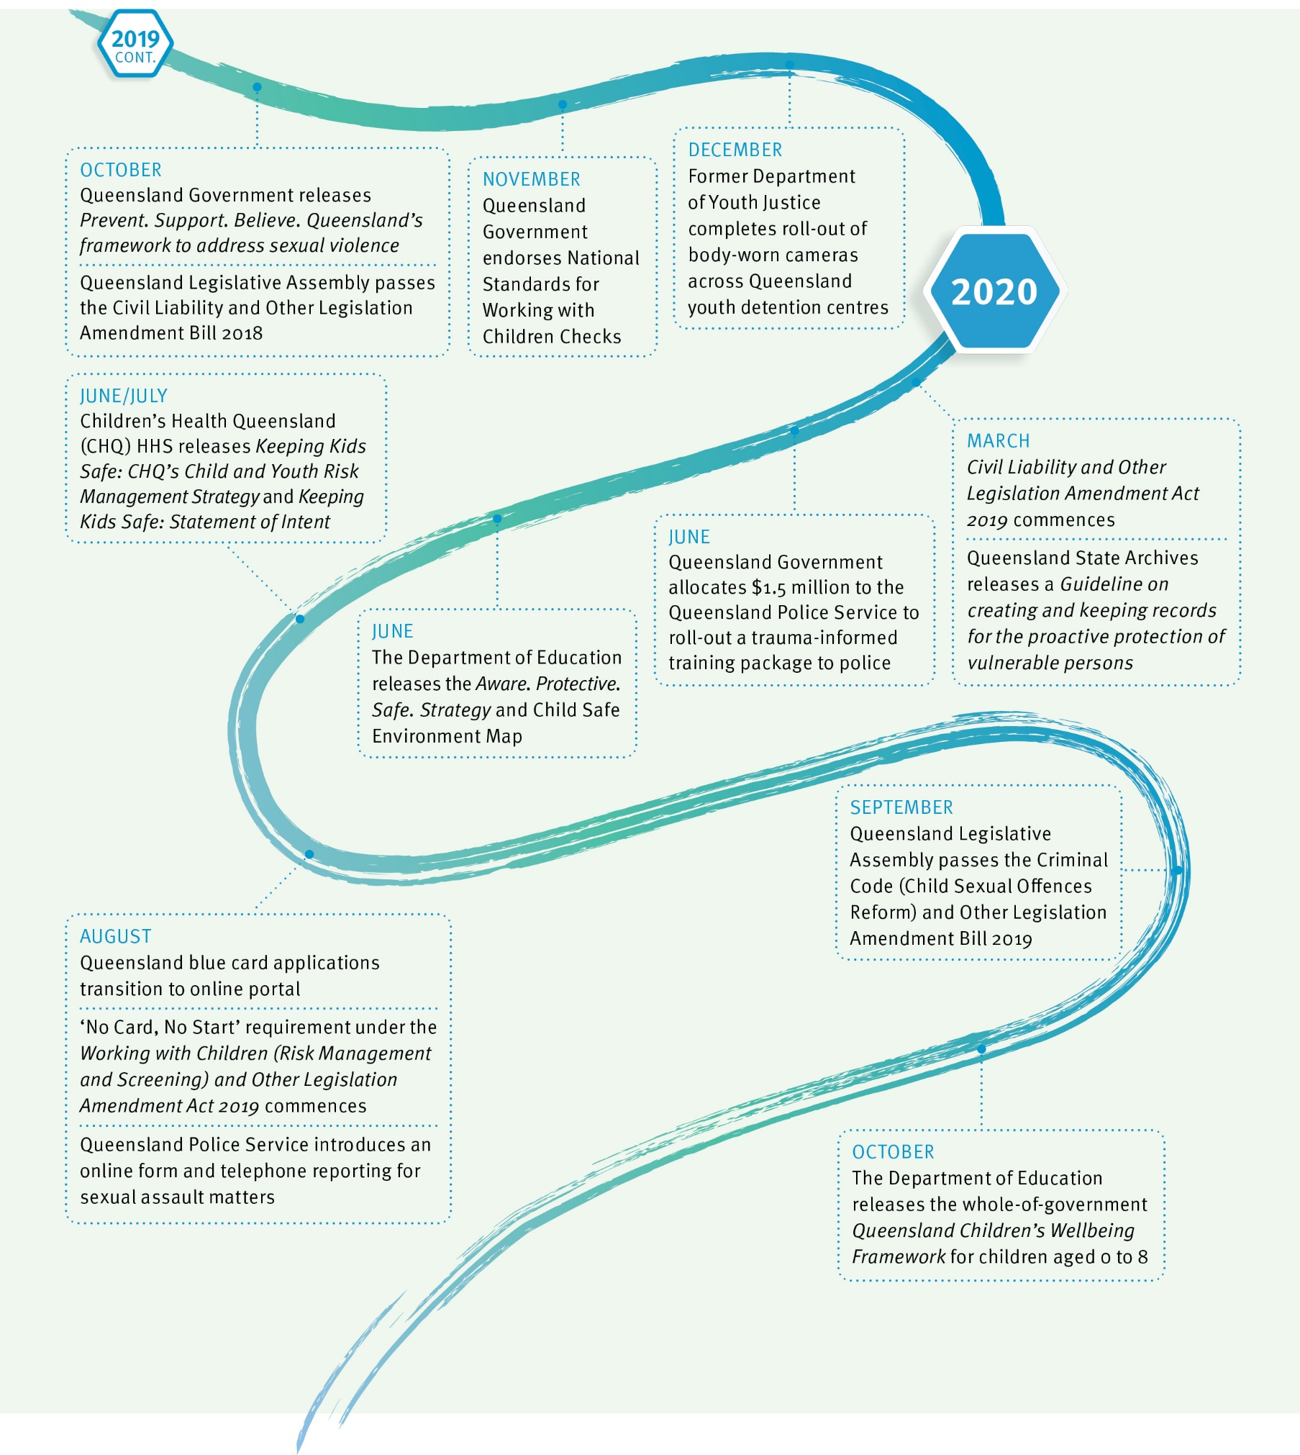

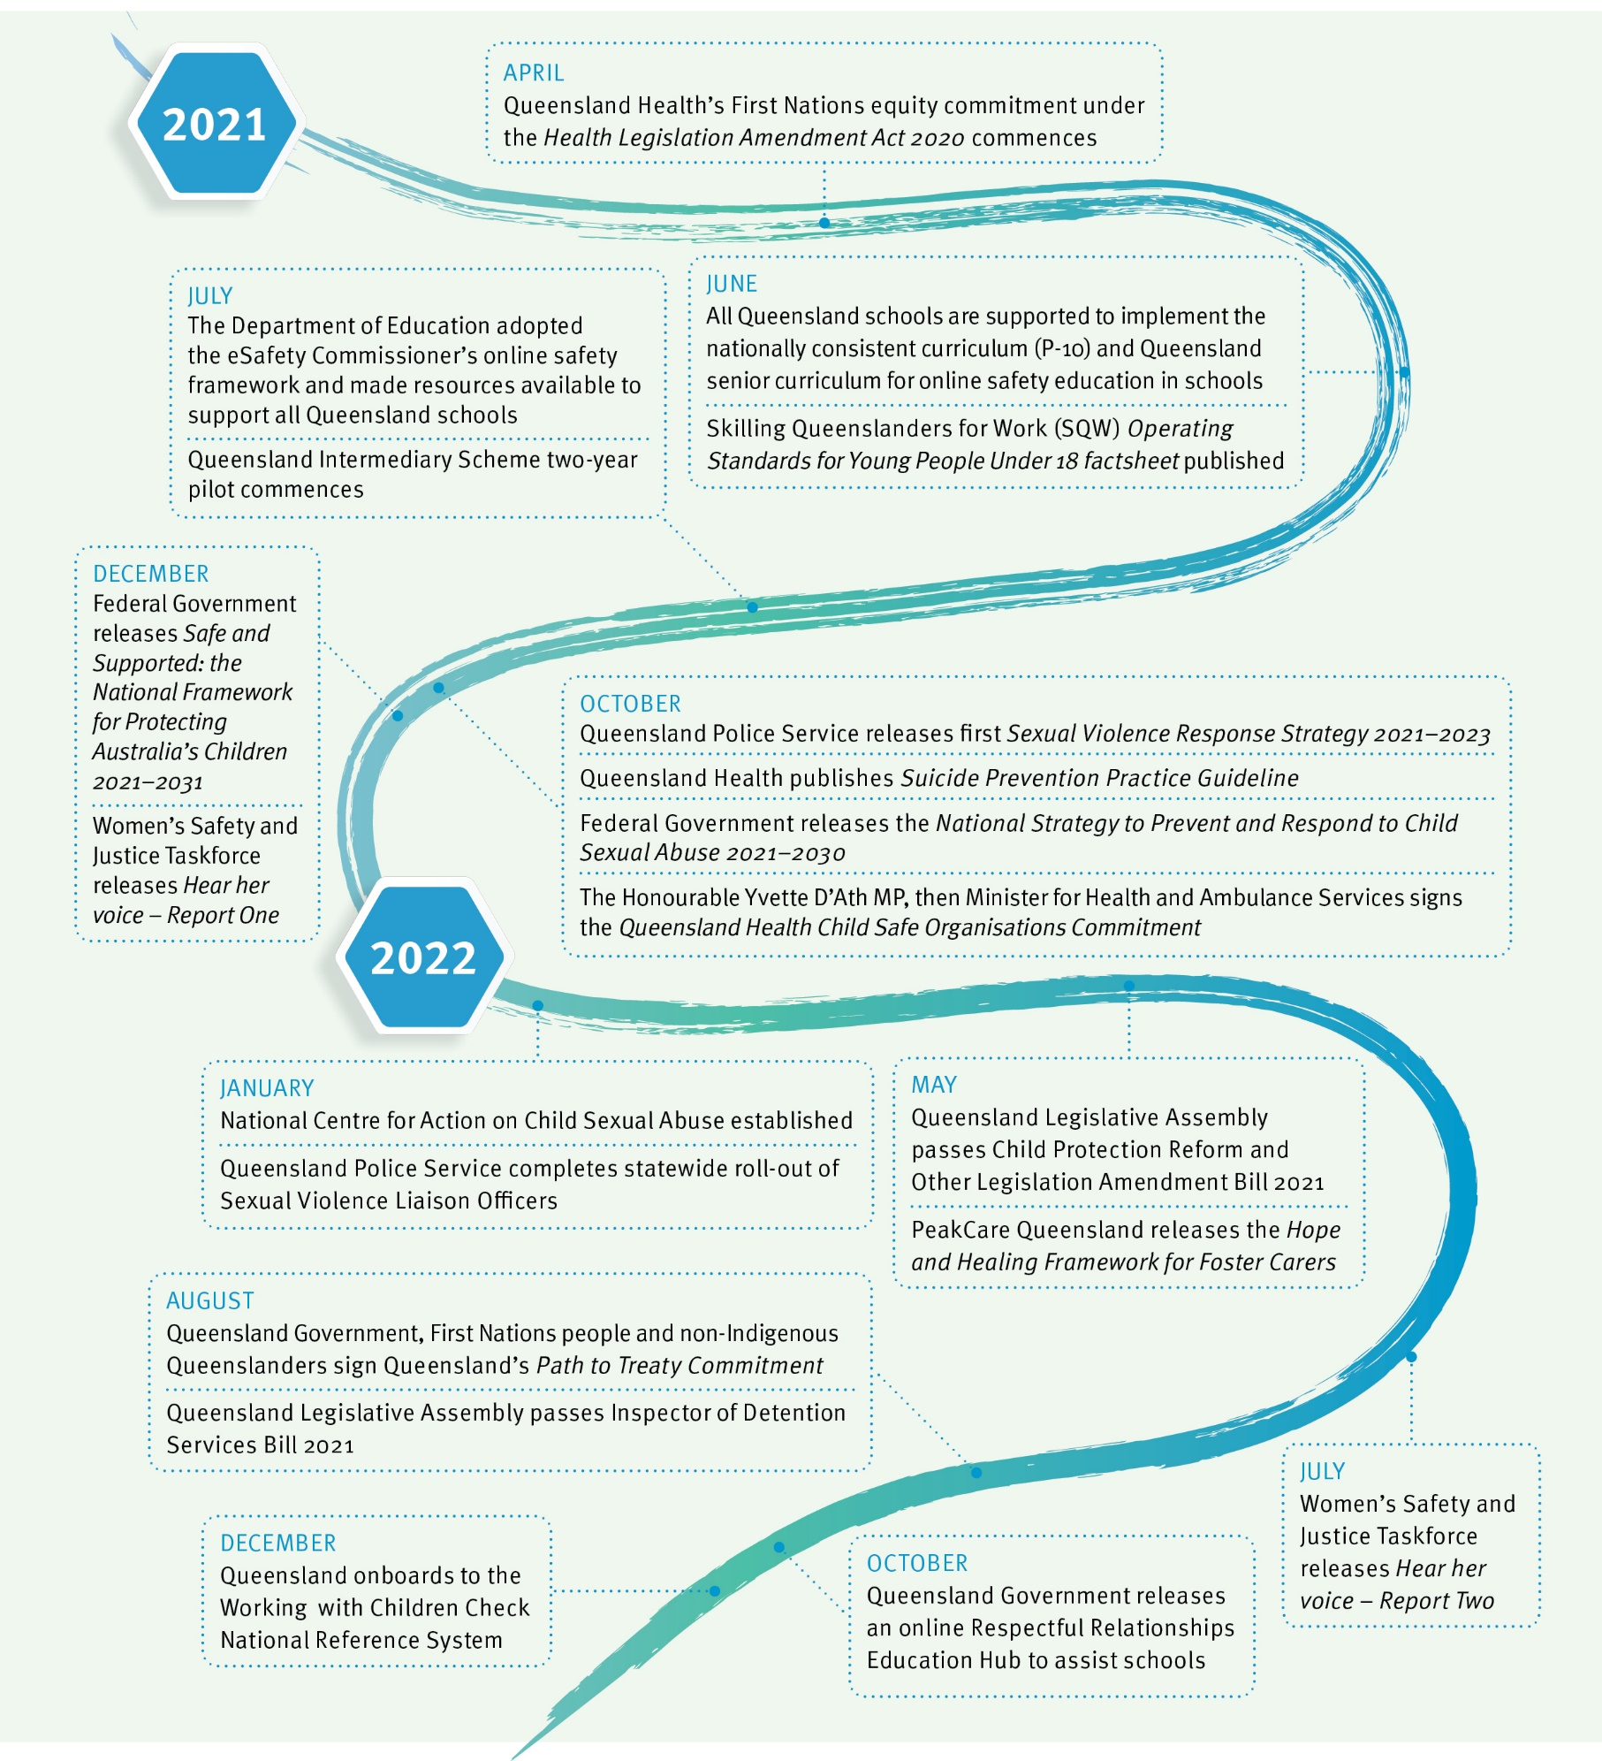

# Snapshot of 2022 progress

In 2022, we have now completed 220 of the 317 recommendations directed to the Queensland Government, either in full or in part, by the Royal Commission. These recommendations are summarised below.

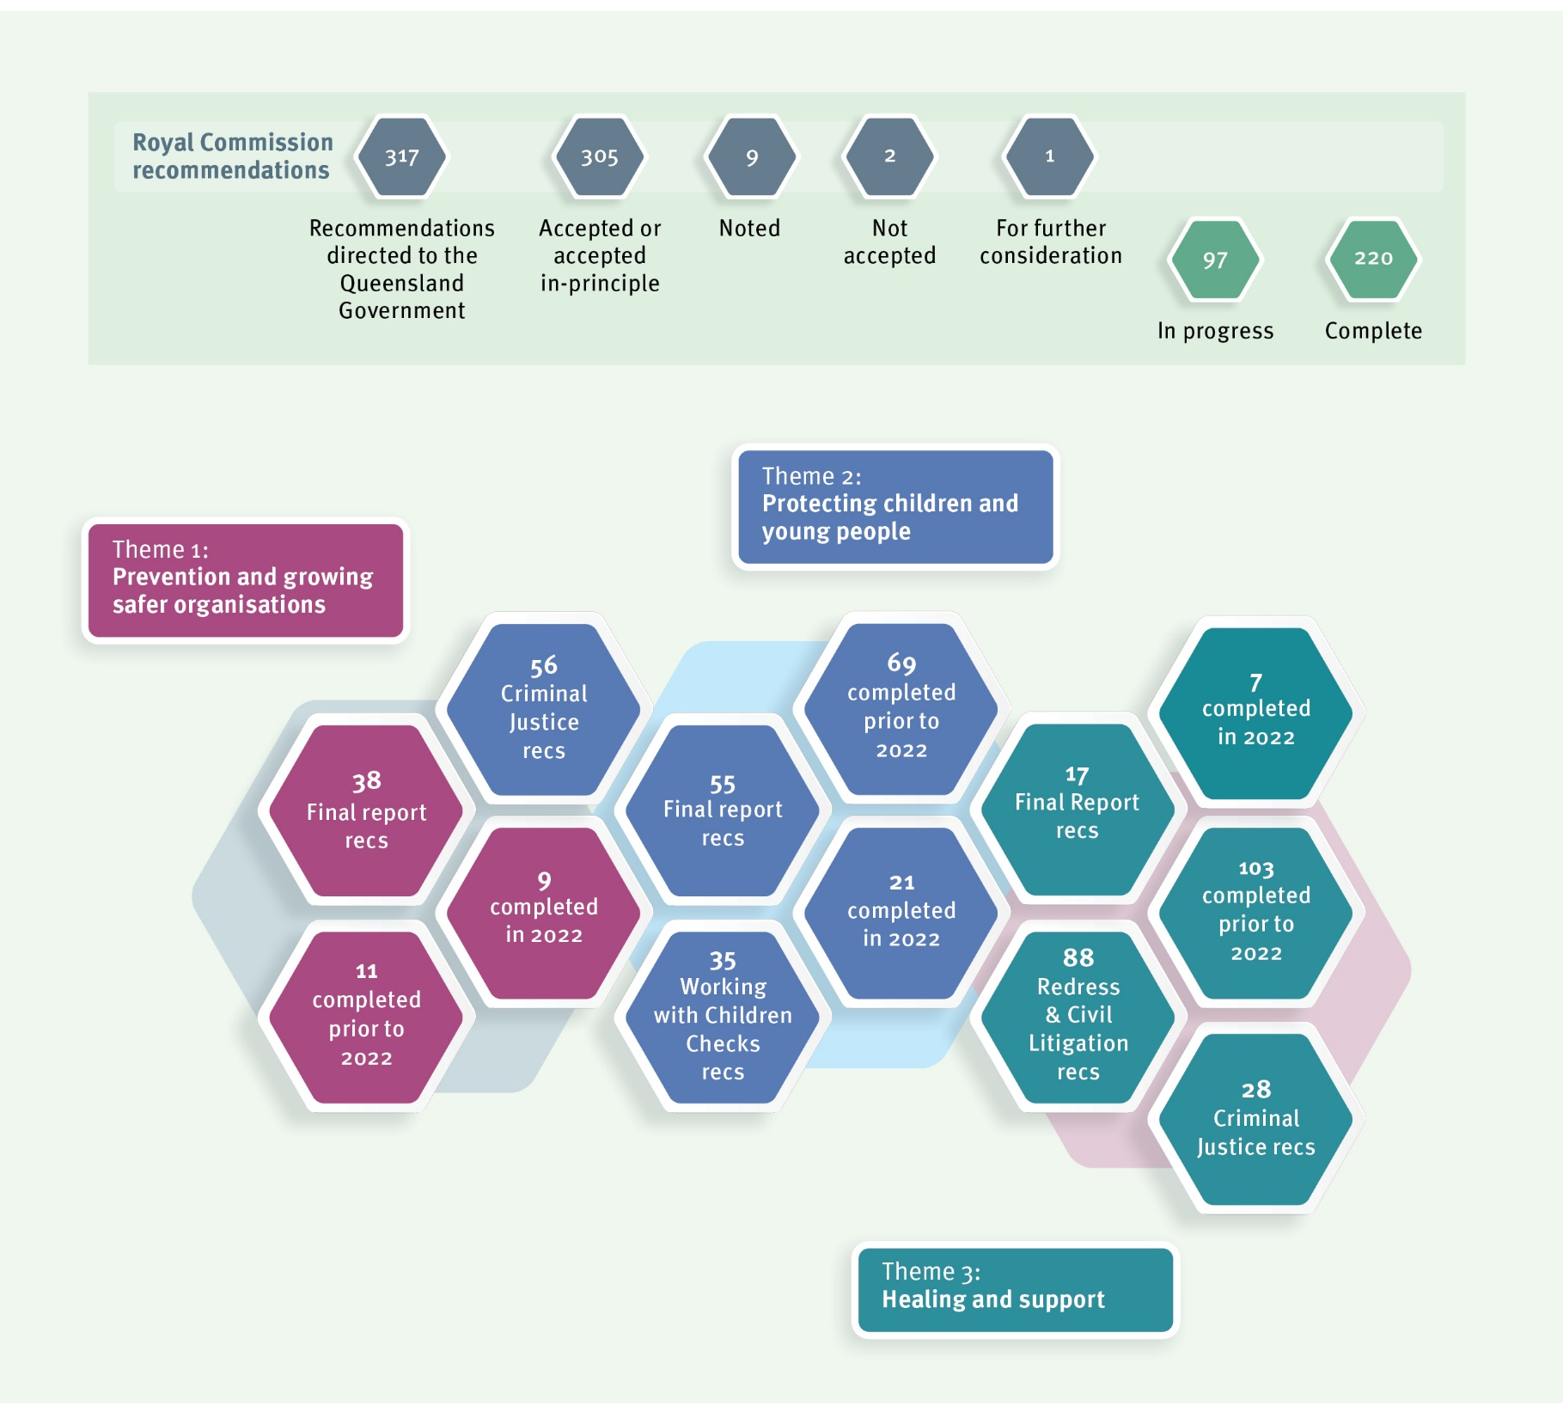

Theme 1

**Healing and**

# 2022 Update from the Truth, Healing and Reconciliation Taskforce

The Truth, Healing and Reconciliation Taskforce (the Taskforce) was established in 2018 to advise the Queensland Government on the implementation of Royal Commission reforms.

The Taskforce is chaired by Mr Robert (Bob) Atkinson, AO APM, former Queensland Police Commissioner and Commissioner of the Royal Commission, and includes membership of:

* four people with lived experience of institutional child abuse;
* two representatives of services that support people with lived experience;
* one representative of care service providers;
* one representative of an organisation that supports children and young people; and
* one representative of religious institutions.

During 2022, the Taskforce met formally four times, focused on three priorities:

1. implementation of the Royal Commission’s recommendations;
2. increasing community awareness of institutional child abuse and its impact; and
3. the National Redress Scheme.
4. Implementation of the Royal Commission’s recommendations

The Queensland Government’s consideration and implementation of Royal Commission recommendations continues to be informed by the expertise and lived experience of Taskforce members.

In 2022, the Taskforce provided advice on the:

* + implementation of the criminal justice reforms recommended by the Royal Commission in its Criminal Justice Report;
  + project underway to develop options to support statewide implementation of child safe standards in Queensland and establish a Queensland reportable conduct scheme;
  + implementation of the *National Strategy to Prevent and Respond to Child Sexual Abuse 2021-2030* and *Safe and Supported: The National Framework for Protecting Australia’s Children 2021-2031*; and
  + design, development and implementation of the National Centre for Action on Child Sexual Abuse.

The Taskforce also met with the Women’s Safety and Justice Taskforce to collectively share what both groups have been hearing from people with lived experience about their involvement with the criminal justice system and how Queensland criminal justice responses could be improved.

1. Community and sector awareness raising activities

##### *Listening Tour*

During 2022, the Taskforce continued its *Listening Tour*, holding community forums across the state. The purpose of the *Listening Tour* is to: raise awareness of institutional child abuse and its impact; hear from people with lived experience, their supporters and service providers; and provide information about the National Redress Scheme. The Taskforce acknowledges the contributions of knowmore Legal Service and Lotus Place (Redress Support Services) in delivering the forums.

Building on forums held in Toowoomba, Cairns, Townsville, Rockhampton, the Sunshine Coast and the Gold Coast, in 2022 the Taskforce travelled to Roma, Mackay, Kingaroy, Cherbourg, Longreach, Emerald, Mount Isa, St George and Warwick.

##### *Presentations*

During 2022, the Taskforce has provided presentations to:

* the CREATE Foundation’s *Voices in Action Conference* with knowmore Legal Service;
* the Queensland Health Child Safe Organisations executive leadership group on the implementation of child safe standards;
* the Daniel Morcombe Foundation’s *Changing Futures Forum*; and
* the fifth National Child Protection Forum.

1. National Redress Scheme

The National Redress Scheme continues to be a priority area of work for the Taskforce. In addition to providing information about the National Redress Scheme as part of its *Listening Tour*, the Taskforce provided advice:

* + to the Queensland Government on the ongoing implementation of the scheme, including the facilitation of direct personal responses and counselling and psychological care in Queensland;
  + in response to the Federal Government’s second-year review of the scheme, including feedback on the development of a *Survivor Service Charter*; and
  + on strategies and actions to support the access to information for children, young people and adults with lived experience of institutional care about their legal rights, including access to redress.

##### *Truth, Healing and Reconciliation Grants Program*

As part of our response to the Royal Commission, the Queensland Government established the Truth, Healing and Reconciliation Grants Program. The purpose of the grants program is to support activities that contribute to truth telling, healing and reconciliation in Queensland; and partner with people with lived experience.

The former Department of Children, Youth Justice and Multicultural Affairs delivered the grants program, with representatives from the Taskforce holding positions of Special Advisors on evaluation panels.

In 2022, the grants program delivered funding totalling almost $50,000 across five projects including:

* + the publication of a manuscript of people’s experiences of Nazareth House by the Queensland Writers Centre and Ms Tess Rowley, child protection resource author;
  + a roundtable on aged and community care services for Forgotten Australians hosted by Micah Projects in partnership with the Forde Foundation and Global Community Resourcing;
  + the establishment of a memorial acknowledging the institutional child sexual abuse that occurred within church-based institutions by the Uniting Church in Australia, Queensland Synod;
  + art therapy workshops with people with lived experience by the Centre Against Sexual Violence; and
  + a reunion of the former men and women of the Cherbourg Dormitory by the Cherbourg Boys and Girls Dormitory Ltd.

Looking forward

Under its Terms of Reference, the Taskforce was scheduled to conclude on 31 December 2022, aligning with the Queensland Government’s commitment to annual reporting.

Due to the impact of the COVID-19 pandemic, the Taskforce has been extended until 31 December 2023. During 2023, the Taskforce will continue its *Listening Tour* to hear from people with lived experience, their supporters and service providers, and progress its priority areas of work.

# Theme 1:

# Prevention and growing safer organisations

## Our progress

The Royal Commission made a range of recommendations, across its several reports, about institutions implementing the 10 child safe standards. This included recommendation 6.7 that the child safe standards should be adopted as part of the National Principles developed by the Community Services Ministers’ Meeting and endorsed by the former Council of Australian Governments (COAG). This recommendation was completed on 19 February 2019 when the National Principles, incorporating the child safe standards, were endorsed by COAG.

In this report we use the terms ‘child safe standards’ and ‘National Principles’ to broadly refer to the Royal Commission’s 10 child safe standards and the *National Principles for Child Safe Organisations* (see below).

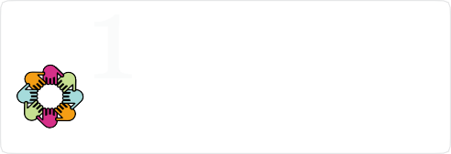

Child safety and wellbeing is embedded in organisational **leadership, governance** and **culture.**

**Policies** and **procedures** document how the organisation is safe for children and young people.

Implementation of the national child safe principles is **regularly reviewed** and **improved**.

**Physical** and **online environments** promote safety and wellbeing while minimising the opportunity for children and young people to be harmed.

**Staff** and **volunteers** are equipped with the knowledge, skills and awareness to keep children and young people safe through **ongoing education** and **training**.

Processes to respond to **complaints** and **concerns** are child focused.

People working with children and young people are suitable and **supported** to reflect child safety and wellbeing values in practice.

**Equity** is upheld and **diverse needs** respected in policy and practice.

Families and communities are **informed** and **involved** in promoting child safety and wellbeing.

Children and young people are informed about their **rights, participate** in decisions affecting them and are taken seriously.

*Figure: National Principles for Child Safe Organisations (source: National Office for Child Safety https://*[*www.childsafety.gov.au/resources/national-principles-child-safe-organisations-poster)*](http://www.childsafety.gov.au/resources/national-principles-child-safe-organisations-poster))

### Child safe standards

In our first annual progress report in 2018, the Queensland Government accepted the child safe standards as informing best practice for departments that provide services to children. Since then, Queensland Government departments have continued to incorporate child safe standards into policies, procedures and practice. Building child safe institutions is an ongoing process that requires continuous review and improvement. In this context, and following four years of implementation, we can now complete recommendations 6.4, 6.5 and 6.6 of the Final Report.

Highlights of our ongoing implementation of child safe standards in 2022 include:

* The Queensland Health *Child Safe Organisations Commitment* indicates Queensland Health has a zero tolerance for child abuse, neglect and harm and is committed to ensuring Queensland Health services and operations align with the National Principles.
* Children’s Health Queensland launched an internal contemporary online child protection education package which aligns with the Queensland Health Child Protection Capability Framework and the child safe standards. It has been publicised to staff and is easily accessible through the Queensland Health education platform. Queensland Health is also finalising the digitisation of its blue card governance systems to ensure all aspects of blue card compliance are up-to-date, efficient and easily accessible.
* The Department of Education continues to maintain the *Aware. Protective. Safe. Strategy* and Child Safe Environment Map to support its approach to keeping all children and young people safe from sexual abuse in Queensland schools and early childhood services. These strategies were highlighted in our previous annual progress reports, and work is continuing to embed the National Principles and ensure child safety is prioritised in Queensland state schools.
* The Department of Education will also work with the Federal Government and state and territory governments on changes to the National Quality Framework to address gaps between the National Principles and the National Quality Framework for children’s education and care services. These amendments are expected to commence from 1 October 2023.
* The former Department of Children, Youth Justice and Multicultural Affairs reflected its commitment to the National Principles in its Strategic Plan for 2022-26. Work is continuing to embed the National Principles into its core business, everyday tasks, actions and decisions to ensure children and young people are safe from harm while being supported by, or requiring support from, the Department of Child Safety, Seniors and Disability Services and the Department of Youth Justice, Employment, Small Business and Training.
* The former Department of Seniors, Disability Services and Aboriginal and Torres Strait Islander Partnerships published a risk management strategy for children, young people and people with disability that incorporates the child safe standards.
* The Department of Housing continues to review and implement opportunities to integrate child safe standards in existing policies, procedures and operational practices to support safe standards for children.
* Sport and Recreation within the Department of Tourism, Innovation and Sport adopted the National Principles and integrated them into its Child and Youth Risk Management Strategy, guideline and training model. This application of the National Principles assists Sport and Recreation to create a child safe culture and implement strategies and actions to prevent harm to children participating in sport and recreation activities across the state.
* The Child Protection Policy and Procedure of the Queensland Academy of Sport provides staff induction and training, requires all staff to hold a blue card and requires health practitioners to be registered with their professional body. Following an external review undertaken in 2022, Queensland Academy of Sport is reviewing all its policies, processes and procedures to strengthen its safeguarding approach.
* As part of the Skilling Queenslanders for Work initiative, the former Department of Employment, Small Business and Training funds training and community-based support for unemployed or underemployed people including young people. To support providers to implement and adhere to the National Principles, Skilling Queenslanders for Work developed the *Operating Standards for Young People Under 18* fact sheet and included the National Principles in tender (grants and funding applications) writing workshops delivered by the Queensland Council of Social Service.
* The former Department of Employment, Small Business and Training also amended its Customer Complaints Management Policy to make it clear, accessible and child focused.

In addition to recommending schools implement the child safe standards, the Royal Commission also recommended (Final Report, recommendation 13.6) that complaint handling policies for schools should include policies and procedures to manage complaints about children with harmful sexual behaviours.

The Department of Education is reviewing complaint handling processes to ensure they are easy to understand and accessible to children and young people, families, staff and volunteers. A child friendly complaint form is already available on the Department of Education’s website, and the review will look for opportunities to further enhance child- friendly and child-focused complaints processes. The aim is to embed better practice among complaints officers and support them to confidently manage complaints by students as well as improve student awareness about how to make a complaint.

The Department of Education is also working to ensure the *Allegations Against Employees in the Area of Student Protection* procedure is accessible to children and supported by child-friendly complaint material. In addition, a guide has been developed to support managers to respond to low level student protection concerns. This guide includes a template and support for taking statements from students. The Department of Education will provide training for interviewing children to further equip staff to elicit complaints and concerns from students and manage them in a child-friendly way. With this work underway, we have changed our position on recommendation 13.6 from ‘For Further Consideration’ to ‘Accept in Principle’.

##### Improving regulation and oversight of child safe practice

The Department of Child Safety, Seniors and Disability Services and the Department of Justice and Attorney-General continued work to identify options to support statewide implementation of child safe standards; and establish a Queensland reportable conduct scheme. These projects have been progressed in concert throughout the year, with both agencies working closely on a coordinated and integrated response.

Informed by the results of targeted consultation undertaken in 2021 on the paper *Growing child safe organisations in Queensland*, a range of options for statewide implementation of child safe standards were developed. The Queensland Government will consider these options to determine the best way forward. With this work underway, we have changed our position on recommendation 6.8 (Final Report) from ‘For Further Consideration’ to ‘Accept in Principle’.

### National initiatives to keep children safe

In our 2021 annual report, we noted that two national approaches to child protection were developed with the release of *Safe and Supported: The National Framework for Protecting Australia’s Children 2021-2031* (Safe and Supported) and the *National Strategy to Prevent and Respond to Child Sexual Abuse 2021-2030* (National Strategy).

Both *Safe and Supported* and the National Strategy will be implemented through a series of action plans over the next 10 years. The Queensland Government remains committed to working on implementation with the Federal Government, state and territory governments, and other organisations and groups.

##### *Safe and Supported*

Since the publication of *Safe and Supported* on 8 December 2021, the Queensland Government has contributed to developing its first two Action Plans. The Safe and Supported First Action Plan and the Safe and Supported Aboriginal and Torres Strait Islander First Action Plan (the Action Plans) will run from 2023 to 2026.

The Action Plans detail dedicated strategies and actions to achieve the vision and goal of *Safe and Supported*. The Aboriginal and Torres Strait Islander First Action Plan recognises that Aboriginal and Torres Strait Islander children and families have unique needs and strengths that must be considered in implementing nationally consistent approaches to child protection challenges.

The Action Plans were developed in partnership with the Federal Government, states and territories and the Aboriginal and Torres Strait Islander Leadership Group. Development of the Action Plans also included advice from the National Coalition on Child Wellbeing Steering Group, the National Children’s Commissioner and agencies across the Queensland Government.

The Action Plans focus on opportunities for collective effort through a national approach. This includes working across sectors relevant to child protection including health, disability, housing, education and justice.

Both Action Plans target effort toward the *Safe and Supported* Focus Areas:

* Focus Area 1: A national approach to early intervention and targeted support for children and families;
* Focus Area 2: Addressing the over-representation of Aboriginal and Torres Strait Islander children in child protection systems;
* Focus Area 3: Improving information sharing, data development and analysis; and
* Focus Area 4: Strengthening the child and family sector and workforce capability.

The Action Plans are supported by an Outcomes Framework and Theory of Change.

A Monitoring and Evaluation Strategy is also being developed so that progress is transparent and accountable. The Queensland Government will participate in all levels of the governance structure for implementation.

The Action Plans and supporting documents were published on 31 January 2023. The Department of Child Safety, Seniors and Disability Services will implement the Action Plans in partnership with the Federal Government, states and territories and the Aboriginal and Torres Strait Islander Leadership Group.

More information about *Safe and Supported* can be found on the Federal Government’s website: https://[www.dss.gov.au/our-responsibilities/families-and-children/programs-](http://www.dss.gov.au/our-responsibilities/families-and-children/programs-) services/protecting-australias-children.

##### *National Strategy*

The National Strategy represents a shared commitment by federal, state and territory governments to prevent child sexual abuse and support and empower people with lived experience of child sexual abuse.

The National Strategy is a key recommendation of the Royal Commission. It is a ten-year approach that provides a framework for reducing the risk, extent and impact of child sexual abuse and related harms in Australia.

The National Strategy has five priority themes:

* Theme 1: Education and building child safe cultures;
* Theme 2: Supporting and empowering victims and survivors;
* Theme 3: Enhancing national approaches to children with harmful sexual behaviours;
* Theme 4: Offender prevention and intervention; and
* Theme 5: Improving the evidence base.

During 2022, the Queensland Government has continued to work in partnership with the Federal Government and states and territories on implementing the National Strategy’s First National Action Plan (2021-2024). This important work contributes to consistency

in policy responses across jurisdictions and supports consultation and shared decision- making on ways to prevent and better respond to child sexual abuse.

More information about the National Strategy can be found on the Federal Government’s website: https://childsafety.pmc.gov.au/what-we-do/national-strategy-prevent-child- sexual-abuse.

### Prevention in Queensland schools

The Royal Commission recommended the National Strategy include prevention education for children, parents, community members and people training to work with children. The Royal Commission also recommended (Final Report, recommendation 13.6) that guidance be provided to teachers and principals on preventing and responding to child sexual abuse in schools.

In our 2021 annual progress report, we mentioned that the Federal Government had commissioned the Australian Institute of Family Studies to develop nationally consistent guidance for teachers and principals on the prevention of child sexual abuse. These guidelines focus on developing a child safe culture where child sexual abuse is prevented before it can occur. With the guidelines now available on the Department of Education’s Student Wellbeing Hub, the Department of Education is working on how to support the implementation and distribution of the guidelines across Queensland schools.

The Department of Education is committed to prevention education for children in Queensland schools that is age-appropriate, informs them of their rights and keeps them safe. The Respectful Relationships Education Program is a key part of Queensland’s approach and is mandatory in all Queensland state schools.

##### *Respectful relationships*

In October 2022, the Queensland Government released an updated and upgraded suite of resources for respectful relationships education, including the new Respectful Relationships Education Hub. New and strengthened information on concepts like consent education, reporting of sexual assault, ethical decision-making, coercive control, forms of abuse and drivers of gender-based violence have been incorporated into the new program.

##### *Online safety for children and young people*

The Department of Education supports every child and young person in Queensland state schools to learn and engage safely in the digital world. Schools focus on the prevention of harm through education and awareness that provides the skills children and young people need to be safe in online environments.

As outlined in our 2021 annual report, we adopted the online safety framework developed by the eSafety Commissioner and developed *Online Safety in Queensland State Schools* to provide guidance on how to respond to online safety and support schools, students, parents and the community to keep young people safe online. A statewide professional development program was implemented to support capability and knowledge building of the Department of Education’s behaviour management procedures with school principals and leadership teams. In addition, new fact sheets for principals and school staff on school responsibilities related to cyber bullying were developed.

To support non-state schools to respond to issues of online safety, formal relationships were established with peak bodies for the non-state schooling sector, including Independent Schools Queensland and the Queensland Catholic Education Commission to provide:

* assistance and/or advice in serious incidents of offensive content;
* access to the full suite of Department of Education resources; and
* regular online safety forums with key representatives from all sectors to share information and to discuss online issues, policies and procedures, and coordinate responses to contemporary online incidents.

In addition, Queensland schools are supported to implement the nationally consistent curriculum (P–10) and Queensland senior curriculum for online safety education. Building on our work in 2020 developing online safety resources for upper primary students (Years 4 to 6) and upper secondary students (Years 11 and 12), a revised version of the lower secondary (Years 7 to 10) course was released in January 2022. At this time, a secondary student online safety resource hub to Queensland state schools was also released.

On 8 July 2021, the Department of Education report on the review of the Australian Curriculum was finalised and progressed to the Australian Curriculum, Assessment and Reporting Authority. In 2022, the Department of Education continued to provide advice on the review to ensure refinements to the curriculum will provide schools with core content to support online safety education such as digital technologies and health and physical education.

On 1 April 2022, the Education Ministers Meeting endorsed the revised version of the P-10 Australian Curriculum (Version 9.0). The Department of Education is developing resources and professional learning to prepare Queensland teachers to implement the revised curriculum from 2024 including new aspects of digital literacy, *Practicing Digital Safety and Wellbeing*. With the review of the Australian Curriculum completed and work underway for implementation, our position on recommendation 6.19 has moved from ‘For Further Consideration’ to ‘Accept in Principle’ with this recommendation completed in 2022.

Recently, students have highlighted that they need more information about how to report harm they and their peers experience, as well as how schools respond to concerns or disclosures of sexual abuse and assault. The Department of Education values the views of students and their participation in decision-making and will continue to work on how schools can enhance reporting and responding to harm and improve student communication. The current review of complaints processes to ensure they are child focused will further support this work.

To create safe online environments in institutions, the Royal Commission recommended (Final Report, recommendation 6.21) pre-service education and in-service staff training programs for tertiary students as well as staff and volunteers in schools. Work on this recommendation is progressing nationally with Queensland supporting the inclusion of online safety content into pre-service education for tertiary students.

In Queensland, all school staff members, as well as visitors and volunteers in state schools, are provided with information about resources from the Office of the eSafety Commissioner that support adults to create and maintain child safe online environments. For staff, Office of the eSafety Commissioner professional development resources for educators are promoted in department-wide newsletters and in online Student Protection Training that must be completed annually. The *Key Message Guide for volunteers, contractors and visitors* also includes links to online safety programs.

With these strategies in place, we have changed our position on recommendation 6.21 from ‘For Further Consideration’ to ‘Accept in Principle’ although there is more work to do before we can complete this recommendation.

### Policing online safety

Online child sexual exploitation is a borderless crime. Argos is a specialist unit in the Queensland Police Service working locally, nationally and internationally to share intelligence, collaborate on investigations and build the capacity of other agencies to identify and disrupt online child sexual abuse and exploitation.

The 2021 documentary, *The Children in the Pictures*, focuses on the day-to-day work of international experts, including members of Argos and the Australian Centre to Counter Child Exploitation to prevent, disrupt, and investigate child sexual abuse. The film highlights the innovative investigative strategies that, combined with international law enforcement collaboration, have resulted in the rescue of children from abuse and the prosecution of offenders across the world.

During the 2021-22 financial year, Argos:

* contributed to the identification of 417 children in circumstances of sexual harm nationally and internationally;
* arrested 29 child sex offenders on 145 criminal charges; and
* referred 279 cases to law enforcement agencies nationally and internationally.

##### *Online safety for eSports*

As part of an ongoing partnership with the Queensland University of Technology, representatives from the Queensland Police Service’s Argos unit attended the eSports schools tournaments in late 2021. To enhance online safety, detectives spoke to young people in Years 10–12 to raise awareness and enhance prevention of online exploitation in the context of eSports.

### Child safe youth detention centres

The Royal Commission found that contemporary detention environments present higher levels of risk compared to other institutional contexts. As research indicates children are generally safer in community settings than in closed detention environments, the Royal Commission suggested that children should only be detained as a last resort and for the least possible time, and that all appropriate steps should be taken to ensure their care and protection.

The Royal Commission recommended consideration of the effective use of technology to keep young people safe in youth detention settings including closed-circuit television and body-worn cameras to provide an additional layer of accountability and transparency. The use of closed-circuit television and body-worn cameras in Queensland youth detention centres are continually being improved to protect young people and maintain a high standard of privacy.

The Department of Youth Justice, Employment, Small Business and Training also continues to facilitate access of young people in youth detention centres and their advocates to a complaints management system that is culturally responsive, accountable and transparent. It is important that young people and their support networks have confidence in the complaints system and that it is responsive to their concerns. Youth detention centres do this by:

* continually exploring new strategies to strengthen young people’s confidence in complaints processes to better enable young people to voice their concerns;
* ensuring young people have confidential and unrestricted access to external oversight bodies, for example, through access to a phone that auto-dials external complaints and oversight hotlines; and
* respecting, protecting and promoting human rights through the complaints management system.

The Office of the Public Guardian receives regular information about allegations of harm and complaints relating to young people in youth detention centres. Community Visitors visit youth detention centres each week and advocate for the best interests of young people. Young people can also access a locked letterbox in their accommodation section to post confidential mail and raise complaints directly with the Office of the Public Guardian.

Feedback provided through the complaints process is critical to ensure that services to young people in youth detention centres can continue to improve to maximise their safety, wellbeing and rehabilitation.

##### *Introducing an Inspector of Detention Services*

Established by the *Inspector of Detention Services Act 2022* (the Act), the role of the Inspector of Detention Services (the Inspector) is to independently oversee prisons, police watchhouses and youth detention centres, through a system of regular inspections and reviews.

The Inspector’s main purpose is to promote the improvement of places of detention and detention services with a focus on ensuring humane treatment and conditions of detainees and prevention of harm.

In recognition of the unique vulnerabilities of children in detention environments, the Act provides where the Inspector is conducting a review or inspection in relation to the detention of a child, the Inspector must arrange for a person with appropriate expertise in the areas of child trauma and the prevention and identification of child sexual abuse to help carry out the review or inspection.

The Act also provides that the Inspector may consult with, or engage, professionals and other people to help in the performance of the Inspector’s functions. For example, for its annual inspections of youth detention centres, the Inspector may wish to engage consultants that have expertise in child trauma and the prevention and identification of child sexual abuse.

As part of regularly examining the treatment of persons in places of detention, the Inspector can make public recommendations, for example, the Inspector may recommend actions to promote the improvement of detention services or places of detention.

With the passage of the *Inspector of Detention Services Act 2022* on 30 August 2022, and the appointment of the Queensland Ombudsman as the Inspector of Detention Services, we are completing recommendations 15.2 and 15.10 (Final Report) in 2022.

## Looking forward

From 2023, the Queensland Government will continue our work to prevent child sexual abuse and grow child safe organisations by:

* continuing to improve child safe standards and National Principles implemented by Queensland Government departments;
* determining the best pathway forward for implementing the child safe standards in Queensland;
* continuing to implement *Safe and Supported: The National Framework for Protecting Australia’s Children 2021-2031* and the *National Strategy to Prevent and Respond to Child Sexual Abuse 2021-2030*; and
* continuing to develop resources and professional learning to prepare Queensland teachers to implement the revised Australian Curriculum from 2024.

# Theme 2:

# Protecting children and young people

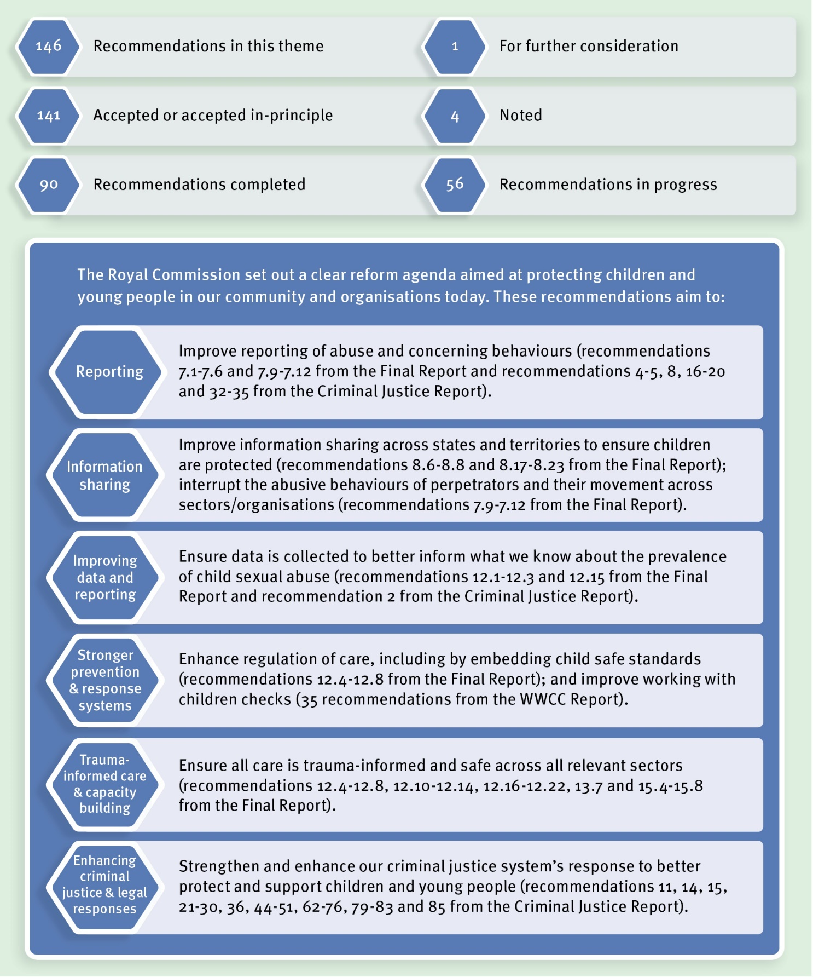

## Our progress

##### *Protecting children through reporting*

During its inquiry, the Royal Commission identified many occasions where child sexual abuse was not reported to external authorities, including child protection, police and regulatory bodies. The Royal Commission made several recommendations in its Final Report and Criminal Justice Report designed to encourage the reporting of child sexual abuse.

In Queensland, anyone can report concerns that a child may be experiencing child abuse, including child sexual abuse, to the Department of Child Safety, Seniors and Disability Services at any time. In addition, some professions are required by law under the *Child Protection Act 1999* to make a report, if they form a reasonable suspicion that a child has suffered, is suffering or is at an unacceptable risk of suffering, significant harm caused by physical or sexual abuse, and may not have a parent willing and able to protect them.

These professions include a doctor, a registered nurse, a teacher, particular police officers, persons engaged to perform a child advocate function under the *Public Guardian Act 2014* and early childhood education and care professionals. The online Child Protection Guide (Final Report, recommendation 7.1) is available to help mandatory reporters and other professionals make the decision to report to the Department of Child Safety, Seniors and Disability Services. Under *the Child Protection Act 1999*, Child Safety staff and care providers are also required to report suspicions of harm experienced by children in care.

With the intent to establish a consistent minimum set of mandatory reporting requirements across states and territories, the Royal Commission recommended care workers, youth justice workers, early childhood workers, registered psychologists and school counsellors and people in religious ministry be covered by mandatory reporting laws in every state and territory (Final Report, recommendations 7.3–7.4).

In Queensland, care and early childhood workers are already included in mandatory reporting laws. Youth justice workers, registered psychologists and school counsellors have policy and practice obligations to report child sexual abuse to police and/or the Department of Child Safety, Seniors and Disability Services. As these groups work closely with children and families on a day-to-day basis, they are well placed to make a report to the Department of Child Safety, Seniors and Disability Services when they are concerned a child is experiencing, or at risk of, child sexual abuse and their parents are not able or willing to protect them. For these professionals, existing policy and practice obligations appropriately promote reporting.

In July 2021, it became a criminal offence in Queensland for any adult not to report sexual offending against a child by another adult to police. This means all adults in the

community are required to report any child sexual abuse to the Queensland Police Service unless the person has a reasonable excuse for not reporting. This obligation covers all professionals identified by the Royal Commission and mandatory reporter groups under the *Child Protection Act 1999*.

Together, these reporting obligations meet the intent of the Royal Commission to encourage reporting of child sexual abuse to the appropriate authorities and recommendations 7.3 and 7.4 are now complete in 2022.

As previously mentioned in this report, the Department of Justice and Attorney-General and Department of Child Safety, Seniors and Disability Services have continued work to identify options to support statewide implementation of child safe standards across Queensland and the establishment of a Queensland reportable conduct scheme.

The Queensland Government will consider the options developed to determine the best pathway forward for Queensland.

##### *Protecting reporters from reprisal*

To protect individuals who make reports in good faith about child sexual abuse, the Royal Commission recommended (Final Report, recommendations 7.5 and 7.6) that state and territory governments ensure legislation provides comprehensive protections for reporters from criminal and civil liability as well as reprisals or detrimental action.

Protections from civil and criminal and professional liability for people that report child protection concerns are currently provided for reporters under the *Child Protection Act 1999*. Similarly, the *Criminal Code Act 1899* provides protections from civil and criminal liability for those reporting a belief of child sexual abuse in good faith. Neither Act contains protections from reprisal or detrimental action towards reporters.

While protections from reprisal for reporters are limited in Queensland, this issue is being considered for existing reporting regimes including as part of the ongoing collaborative work on child safe standards and a Queensland reportable conduct scheme.

Amendments to the Health Practitioner Regulation National Law (National Law) or respective jurisdictional health complaints legislation to implement part (b) of recommendation 7.5 are being discussed nationally.

Protection against reprisals for people who report harm relating to health practitioners has been addressed in Queensland through modifications to the National Law to incorporate provisions of the *Health Ombudsman Act 2013* (Qld).

##### *Reporting to police*

The Queensland Police Service is committed to continuous improvement in responding to child sexual abuse and has introduced a range of initiatives to remove barriers and provide options for people to report sexual violence. In 2020, the Queensland Police Service launched an online sexual assault reporting form and, at the same time, Policelink introduced telephone reporting for non-urgent sexual assault matters. As these new options offer people, including vulnerable members of the community, alternative channels to reporting sexual abuse, recommendation 4 in the Royal Commission’s Criminal Justice Report is now complete.

The Queensland Police Service recognises there are additional barriers for reporting child sexual abuse and sexual violence for Aboriginal and Torres Strait Islander peoples and communities and is committed to developing positive relationships with Aboriginal and Torres Strait Islander communities to encourage the reporting of child sexual abuse experienced by Aboriginal and Torres Strait Islander children. The Queensland Police Service First Nations and Multicultural Affairs Unit, established in 2020, continues to promote and maintain positive and effective relationships with diverse communities and create a culturally inclusive, responsive and capable police service.

##### *Supporting criminal investigations*

In its Criminal Justice Report, the Royal Commission recommended (recommendation 8) that states and territories clarify when the identity of a notifier to the Department of Child Safety, Seniors and Disability Services can be disclosed to a law enforcement agency for the purpose of assisting the investigation of criminal offences against children and young people and safeguarding their safety and wellbeing.

With the passage of the Child Protection Reform and Other Legislation Amendment Bill 2021 on 10 May 2022, the *Child Protection Act 1999* now allows the Department of Child Safety, Seniors and Disability Services to disclose notifier information to a senior police officer in certain circumstances where it is required for the prevention, detection, investigation, prosecution or punishment of a criminal offence and is necessary to ensure the safety, wellbeing and best interests of a child. These circumstances are limited to protect notifier confidentiality, so that members of the community are able to report child protection concerns without fear of potential negative consequences or damaging a protective relationship that a notifier may have with a child. This amendment commenced on 31 October 2022 and we can now complete recommendation 8 in the Criminal Justice Report.

### Protecting children through information sharing

As part of the *National Strategy to Prevent and Respond to Child Sexual Abuse* (National Strategy), the Queensland Government has been working with the Federal Government and other state and territory governments on improvements to information sharing arrangements to strengthen child safety and wellbeing. This work progresses Final Report recommendations 8.6–8.8 and is led by the Information Sharing Working Group under the National Strategy.

##### *Working with Children Checks*

On 10 December 2021, National Cabinet agreed that the Federal Government would work together with state and territory governments to improve the national consistency of Working with Children Checks. This work, led by the National Office for Child Safety, is also being progressed by the Information Sharing Working Group under the National Strategy. In addition to actively participating in these national discussions, the Queensland Government is continuing to implement the recommendations of the Queensland Family and Child Commission’s report, *Keeping Queensland’s children more than safe: Review of the blue card system*.

With this work underway, we have changed our position on recommendations 1, 3, 30, 32 and 33 (Working with Children Checks Report) from ‘For Further Consideration’ to ‘Accept in Principle’. As we are still working through the groups of people who may be exempt from working with children checks, recommendation 14 of the Working with Children Checks Report remains ‘For Further Consideration’.

In Queensland, online processing of Blue Cards went live on 31 August 2020. Since then, until 30 June 2022, 437,381 Blue Card and exemption card applications have been processed. Between that period, the average processing time for online applications made by people without any form of assessable information was just over two business days and the average processing time for online applications made by people with less complex police information was just under 14 business days. These timeframes remain within the benchmarks recommended by the Royal Commission of five working days and less than 21 working days respectively (Working with Children Checks Report, recommendation 27).

##### *Sharing information across schools*

For education settings, the Royal Commission recommended that the then Council of Australian Governments (COAG) Education Council consider the need for nationally consistent provisions in state and territory teacher registration laws (Final Report, recommendations 8.9–8.12).

The Department of Education has collaborated with other states and territories and teacher regulatory authorities to consider opportunities to improve teacher registration information sharing between jurisdictions. This work also involves considering relevant findings of the 2018 National Review of Teacher Registration, as well as recent work by the Australian Institute of Teaching and School Leadership in collaboration with teacher regulation authorities to develop the best practice framework for strengthening child safety and wellbeing. Where relevant, potential child safety issues associated with the introduction of the Australian Government’s Automatic Mutual Recognition of Occupational Registration scheme are also being considered, noting that Queensland is not currently participating in the scheme. As national discussions are continuing, implementation of these recommendations is ongoing.

The Royal Commission also recommended that education policies provide for the exchange of student information when students move to another school (Final Report, recommendations 8.13–8.17). The Department of Education has continued to participate in national discussions on these recommendations through the Education Ministers Meeting and related forums. In Queensland, potential changes to Transfer Note provisions under the *Education (General Provisions) Act 2006* are being considered as part of a review of this legislation. With this work underway, we have changed our position on recommendations 8.13–8.15 from ‘For Further Consideration’ to ‘Accept in Principle’, although there is more work to do before we can complete these recommendations.

##### *Sharing information about carers*

In addition to sharing information across Australia about teacher registration, the Royal Commission recommended information sharing arrangements about carers for children in care by establishing nationally consistent carers registers in each state and territory.

On 10 May 2022, the Queensland Legislative Assembly passed the Child Protection Reform and Other Legislation Amendment Bill 2021 (now *Child Protection Reform and Other Legislation Amendment Act 2022*), which establishes a legislative framework for a carers register in Queensland. The legislation establishes an interim Queensland response to the Royal Commission’s recommendations, with the amendments commencing on 21 May 2023. With the passage of this legislation, recommendations 8.17–8.19 are now complete.

The legislation provides for a regulation to prescribe the information to be included in the carers register, which will provide the flexibility needed to achieve national consistency on the minimum information to be held in each carers register in each jurisdiction. As recommendations 8.20–8.23 provide guidance on how nationally consistent carers registers may operate, these recommendations require ongoing implementation pending potential further national discussion.

### Improving data in child protection

In its Final Report, the Royal Commission made several recommendations designed to improve reporting about children in care. This includes abuse experienced by children in care (recommendations 12.1 and 12.2), their vulnerability to child sexual exploitation (recommendation 12.15) and their health, wellbeing and permanency of care status (recommendation 12.3). A theme of these recommendations was that definitions and reporting should be nationally consistent.

On 10 December 2021, the Australian Institute of Health and Welfare released the first national report on *Safety of children in care 2020-21*. The report published a nationally agreed definition of child sexual abuse, completing recommendation 12.1. This report also published information from all Australian jurisdictions, including Queensland, on substantiations of abuse experienced by children in care. This information partly responds to recommendation 12.2. The Australian Institute of Health and Welfare will continue to publicly report this information each year.

The Department of Child Safety, Seniors and Disability Services will continue to work in partnership with the Australian Institute of Health and Welfare, the Federal Government and other state and territory governments to achieve more comprehensive national reporting about safety in care, so that we can complete recommendations 12.2 and 12.15.

In response to recommendation 12.3, all states and territories continued to report about children’s safe return home and permanent care in the *Report on Government Services* published by the Federal Government Productivity Commission. However, national work to report on the health and wellbeing of children in the *Report on Government Services* remains ongoing with more work required to implement recommendation 12.3. Some of this national work will be progressed as part of implementing *Safe and Supported*. In the interim, the Productivity Commission has published new content in the 2023 *Report on Government Services* that summarises how jurisdictions, including Queensland, currently measure the health and wellbeing of children in care locally, including data where available.

The Queensland Government remains committed to transparently reporting data on children in care with information available on the Our Performance website of the Department of Child Safety, Seniors and Disability Services. Information on abuse in care is referred to as harm reports and harm substantiations. The Department of Child Safety, Seniors and Disability Services will continue to improve how information about abuse in care can be better recorded in its existing case management system, ICMS, as well as its new system, Unify, which is currently under development.

In addition to data on abuse in care, information about children’s wellbeing and permanency is also included on the Our Performance website. The Department of Child Safety, Seniors and Disability Services is continuing to develop new indicators for future reporting on this website, including in relation to legal permanency.

The Our Performance website can be found at: <https://performance.cyjma.qld.gov.au>.

### Protecting children and young people in care

##### *Hearing children’s voices*

The safety and wellbeing of children and young people in care continues to be a priority for the Queensland Government. The Royal Commission recognised the vulnerability of children and young people in care and heard directly from them in private sessions, public hearings and through its policy and research program.

In 2022, the former Department of Children, Youth Justice and Multicultural Affairs strengthened its approach to hearing from children and young people in the child protection system through legislative amendments designed to strengthen children’s voices in decisions that affect them. The *Child Protection Reform and Other Legislation Amendment Act 2022* received assent on 20 May 2022, amending the *Child Protection Act 1999* to introduce participation principles to ensure children and young people are provided with meaningful and ongoing opportunities to have a voice, and that genuine attempts are made to understand and consider their views.

The Royal Commission also found that policies and practices that are shaped by children’s views can better prevent harm to children; for example, children may be able to identify risks that are less visible to adults in institutions. Recognising this, the amendments

also require the chief executive (Child Safety) to ensure children have meaningful and ongoing opportunities to participate in decisions about programs and services related to the protection of children, promoting the safety of children and to the extent that it is appropriate, supporting families caring for children.

##### *Oversight and regulation of child protection in Queensland*

As well as encouraging child protection services to listen to the voices of children and young people (Final Report, recommendation 12.10), the Royal Commission made several recommendations to improve the oversight and regulation of child protection services. These recommendations cover the accreditation of out-of-home care services (Final Report, recommendations 12.4 and 12.5) and the assessment and review of the suitability of carers to care for children and young people.

Queensland’s child protection system is supported by robust independent oversight mechanisms. Independent regulation of service providers is supported through the complementary Working with Children Check (Blue Cards) system and the Human Services Quality Framework managed by the Department of Child Safety, Seniors, Disability Services. In addition, the Queensland Family and Child Commission provides independent oversight of the child protection system, and the rights of children and young people are protected by the community visitor and child advocacy functions of the Office of the Public Guardian.

Our previous annual progress reports have described our work on the regulation of care in Queensland over several years, including implementing recommendations from the 2017 Queensland Family and Child Commission inquiry, *Keeping Queensland’s children more than safe: Review of the foster care system*. In July 2019, the then Department of Child Safety, Youth and Women released a public discussion paper, *Rethinking rights and regulation: Towards a stronger framework for protecting children and supporting families*. This work culminated with the passage of the Child Protection Reform and Other Legislation Amendment Bill 2021 on 10 May 2022.

In light of the progress made in improving the regulation of care, and the independent oversight provided by other agencies, recommendation 12.5 is now complete. While the Department of Child Safety, Seniors and Disability Services will maintain responsibility for the accreditation and auditing of out-of-home care service providers through the Child Safety licencing process, the intent of the Royal Commission’s recommendation has been met through the review of the regulation of care and existing strong oversight arrangements.

As part of recommendation 12.4, the Royal Commission recommended that accreditation schemes for child protection services should incorporate compliance with the child safe standards. As implementation of this recommendation is partially dependent on statewide implementation of child safe standards in Queensland, there is more work to do before we can complete this recommendation. As previously mentioned, the Department of Child Safety, Seniors and Disability Services is progressively implementing actions under its Roadmap to embed the National Principles into its child protection services.

##### *Reviews of carers*

The Royal Commission recognised that having regular reviews of carers is an important accountability mechanism for maintaining confidence in the quality and competence of carers. The Royal Commission also highlighted the importance of children in care having their voices heard as part of carer review processes.

Queensland has comprehensive screening and oversight processes in place for carers. In our 2021 annual progress report, we completed recommendation 12.6 (Final Report) relating to the authorisation of carers. In that report, we described how our screening and assessment processes have been strengthened by expanding mandatory checks and the ‘No Card, No Start’ Blue Card requirements. We also noted that carer authorisation relates to recommendations we have implemented from the Queensland Family and Child Commission’s *Keeping Queensland’s children more than safe: Review of the foster care system report*.

We can now complete recommendation 12.7 (Final Report) which recommends that interviews with children in the placement are included in annual reviews of carers. In Queensland, if there are concerns about the care that a child is receiving, it is investigated through a harm report, a standards of care review, or by monitoring the standards of care. These actions can occur at any time and may lead to a review of the carer agreement or the suitability of the carer.

Child safety officers are required to meet with children in care at least once every month. It is recommended that the child safety officer talks with the child alone and is mindful of the child’s physical environment and interactions between household members. A review of a child’s care arrangements can be prompted through these meetings or other contact a child safety officer has with a child or reported to Child Safety by people in the child’s support network.

With the passage of the Child Protection Reform and Other Legislation Amendment Bill 2021 on 10 May 2022, the duration of carer certificates has been extended from two years to three years, commencing from 31 October 2022. This applies to applications for renewal only, with the 12-month duration of an initial approval remaining in place to allow the Department of Child Safety, Seniors and Disability Services to more closely monitor and re-assess new carers. This is intended to remove unnecessary regulatory burden on carers, the agencies that support carers and the Department of Child Safety, Seniors and Disability Services while maintaining an appropriate level of rigour.

##### *Strengthening foster and kinship care*

In our 2021 annual progress report, we noted that we were continuing to work with PeakCare Queensland to adapt the *Hope and Healing Framework for Residential Care* to meet the needs of foster carers. *Hope and Healing* is foundational trauma-informed training for carers to respond to the needs of children and young people from a therapeutic approach. In 2022, the former Department of Children, Youth Justice and Multicultural Affairs launched *Hope and Healing for Foster Care*, which provides tailored e-learning modules for Queensland foster carers.

The Department of Child Safety, Seniors and Disability Services is committed to working with parents, families and carers to support kin to care for children and to increasing the proportion of children in kinship care, including Aboriginal and Torres Strait Islander children. In 2022, new place-based approaches are being implemented to help increase kinship care. A stand-alone kinship care program is also being created in recognition of the particular needs of kinship carers. With this work well underway, we can now complete recommendation 12.8 from the Royal Commission’s Final Report.

### Supporting Aboriginal and Torres Strait Islander peoples

##### *Our Way, Changing Tracks and Breaking Cycles*

The Royal Commission heard that Aboriginal and Torres Strait Islander children and young people are safest when they are connected to their families, communities, culture and country. In partnership with Family Matters Queensland, the Queensland Government remains committed to *Our Way: A generational strategy for Aboriginal and Torres Strait Islander children and families 2017–2037* (*Our Way*).

The vision of *Our Way* is that all Aboriginal and Torres Strait Islander children and young people in Queensland grow up safe and cared for in family, community and culture. Our target is to improve life outcomes for Aboriginal and Torres Strait Islander children and families and eliminate the disproportionate representation of Aboriginal and Torres Strait Islander children and families in the child protection system by 2037. This contributes to the National Agreement on Closing the Gap, where Target 12 seeks to reduce the rate of over-representation of Aboriginal and Torres Strait Islander children in care by 45 per cent by 2031.

The Queensland First Children and Families Board continues to provide strategic guidance and oversight for the implementation of *Our Way*.

*Changing Tracks 2020-2022* is the second action plan, which sets the foundations for change across the Queensland child protection system to achieve our vision and target. Of its 24 actions, 20 actions are complete and/or continue as part of core business. The four remaining actions are being considered for potential inclusion in *Breaking Cycles*, the second implementation phase of the *Our Way* strategy.

Co-design of the third action plan, *Breaking Cycles 2023-25*, is underway, led jointly by the Department of Child Safety, Seniors and Disability Services and the Queensland Aboriginal and Torres Strait Islander Child Protection Peak on behalf of Family Matters Queensland.

The focus of Breaking Cycles is on ‘changing the way that services are designed and delivered for Aboriginal and Torres Strait Islander children and families’.

*Breaking Cycles 2023-25* will be informed by and aligned with the Family Matters Building Blocks, the Queensland Government commitments under Closing the Gap, Path to Treaty, Local Thriving Communities, the priorities outlined in Safe and Supported and the independent evaluation of *Our Way, Changing Tracks*.

The evaluation has shown that positive changes are emerging in:

* Policy and legislative settings that impact Aboriginal and Torres Strait Islander children and families in Queensland.
* Collaborative working approaches between government agencies, partners and service providers to implement *Our Way* that reflect the broader community’s aspirations for self-determination.
* Increasing investment in Aboriginal and Torres Strait Islander community-controlled services and their workforce to better reflect the proportion of Aboriginal and Torres Strait Islander peoples accessing these services.
* Continued implementation of delegated authority to permit one or more of the statutory functions or powers of the chief executive (Child Safety) under the *Child Protection Act 1999* to be delegated to the chief executive officer of an Aboriginal and Torres Strait Islander entity when certain requirements are met. As of December 2022, delegations have been progressed in relation to 59 children and planning for statewide implementation is underway in partnership with the Queensland Aboriginal and Torres Strait Islander Child Protection Peak.
* Increased opportunities for Aboriginal and Torres Strait Islander families to participate in child protection decisions that affect their lives through an independent person or entity and the Family Participation Program.
* Continued investment in Aboriginal and Torres Strait Islander Family Wellbeing Services, delivered by Aboriginal and Torres Strait Islander community-controlled organisations, to support families to care for their children. A recent outcomes evaluation of these services identified positive outcomes in successfully meeting the needs of Aboriginal and Torres Strait Islander families and reducing the extent to which families experienced child protection investigations after exiting the program. In addition, an independent evaluation of the services has found a high level of success in addressing family needs and reducing risks for Aboriginal and Torres Strait Islander families. Of the Aboriginal and Torres Strait Islander children who had the majority (or all) of their needs met, 89 per cent had no further contact with Child Safety within the following six months.
* Improved relationships, greater trust in, and empowerment of, Aboriginal and Torres Strait Islander community-controlled organisations that is resulting in improved access to culturally appropriate services.

##### *The Aboriginal and Torres Strait Islander Child Placement Principle*

To maintain cultural connections of Aboriginal and Torres Strait Islander children and young people, the Royal Commission recommended the full implementation of the Aboriginal and Torres Strait Islander Child Placement Principle (Final Report, recommendation 12.20). The Aboriginal and Torres Strait Islander Child Placement Principle is a cornerstone of contemporary child protection and recognises that empowerment and self-determination of families and communities is central to its application.

The five elements of the Aboriginal and Torres Strait Islander Child Placement Principle were legislated in Queensland in 2018. This legislation has been strengthened by the *Child Protection Reform and Other Legislation Amendment Act 2022*, which requires the application of the five elements to the standard of ‘active efforts’ when making a significant decision about an Aboriginal and Torres Strait Islander child. Active efforts is defined as purposeful, thorough and timely efforts to apply the Aboriginal and Torres Strait Islander Child Placement Principle.

With the passage of this legislation, the Aboriginal and Torres Strait Islander Child Placement Principle is now fully reflected in Queensland’s legislation, policy and practice and compliance is routinely measured through operational performance and case reviews.

In addition, to support Aboriginal and Torres Strait Islander peoples caring for Aboriginal and Torres Strait Islander children, the Queensland Aboriginal and Torres Strait Islander Child Protection Peak and partners in the community-controlled sector are leading, with support from the Department of Child Safety, Seniors and Disability Services, the development and implementation of a new Aboriginal and Torres Strait Islander Family Caring for Family program. This program includes an Aboriginal and Torres Strait Islander kinship care service model.

With this work well underway, we are in a position to complete recommendation 12.20. However, we recognise that sustained effort and commitment is required to continue to embed the Aboriginal and Torres Strait Islander Child Placement Principle into our daily work and to enhance and grow our practice in partnership with Aboriginal and Torres Strait Islander peoples and communities over time.

Another area of ongoing work relates to national reporting about the extent to which states and territories are applying the Aboriginal and Torres Strait Islander Child Placement Principle. On 26 August 2022, the Australian Institute of Health and Welfare released its report, *The Aboriginal and Torres Strait Islander Child Placement Principle Indicators* (2020-21). The Department of Child Safety, Seniors and Disability Services will continue to work with the Federal Government and states and territories to improve national reporting on the application of the Aboriginal and Torres Strait Islander Child Placement Principle.

### Strengthening support for children and young people in care

##### *Responding to children with harmful sexual behaviours*

The Royal Commission identified that responding to children with harmful sexual behaviours is a significant issue facing child protection agencies. In addition to the national work underway through the *National Strategy to Prevent and Respond to Child Sexual Abuse*, the Department of Child Safety, Seniors and Disability Services draws on expert advice to respond to children with harmful sexual behaviours by:

* supporting child safety officers by providing access to expert advice from our Practice Advice and Support team; and
* funding 10 Evolve Therapeutic Services across the state to provide specialist intensive trauma-informed mental health services for children in care with severe and complex psychological and/or behavioural issues.

##### *Supporting young people’s transition to independence*

The Royal Commission recommended (Final Report, recommendation 12.22) that transition from care programs should include support for young people who experienced sexual abuse while in care. In Queensland, in addition to support provided from child safety officers, the Department of Child Safety, Seniors and Disability Services funds eight Next Step Plus services to assist young people aged 15 to 25 to access the practical and therapeutic support they need to transition from care, based on their individual experiences and circumstances.

On 18 June 2022, the Queensland Government announced an expansion to the support offered to young people as they exit care. From mid-2023, the care allowance will be extended by two years for the carers of young people who remain living with them, until the young person turns 21 years of age. Culturally appropriate non-government case worker support and financial support for young people leaving residential care will also be funded. As the details of this expanded program are developed, the Department of Child Safety, Seniors and Disability Services will talk with young people about what kinds of support they want to ensure the program meets their needs and supports their success as young adults.

### Protecting children and young people in youth detention

Queensland’s youth detention centres are committed to providing a safe environment for young people. Policies and procedures embed human rights and work continues with various oversight bodies to ensure the safety and protection of the rights of young people.

Many young people in youth detention have experienced trauma including child abuse and neglect. To support the safety, wellbeing, rights and rehabilitation of young people, youth detention centres operate according to trauma-informed practice principles. As well as individualised case management and positive behaviour support, young people access therapeutic and psychological support though multi-disciplinary teams of clinical psychologists, Aboriginal allied health workers and psychiatrists. When exiting youth detention centres, young people are proactively referred to services to support their continuity of care.

As training and professional development of staff is an ongoing requirement in youth detention centres, we are completing recommendation 15.6 of the Royal Commission’s Final Report in 2022. Training and professional development activities are tailored to the individual needs and vulnerabilities of young people and support the ongoing development of staff knowledge, skills and capacity to recognise and respond to the needs of young people with disability, young people with mental health and/or alcohol and drug issues and young people from culturally and linguistically diverse backgrounds.

For example, a training program has been developed on communicating with young people, including young people from culturally and linguistically diverse backgrounds and young people with disability. The training also explores the differences between Aboriginal and Australian English. Mental health training is also available covering: the impact of mental health on communication; the impacts of drug and alcohol use on young people’s development; and how substance abuse can be used to self-medicate in response to childhood trauma.

Continual improvement of the cultural competency of all youth detention staff is a priority. Youth detention centres rely on the perspectives of Aboriginal and Torres Strait Islander peoples, value their cultural wisdom and knowledge, and ensure the experiences of Aboriginal and Torres Strait Islander young people are understood and responded to in a way that promotes healing and cultural identity. This work also contributes to implementing the National Agreement on Closing the Gap, where Target 11 seeks to reduce the rate of over-representation of Aboriginal and Torres Strait Islander young people 10 to 17 years who are in detention by at least 30 per cent by 2031.

As there are a range of ongoing strategies in place to provide for the cultural safety of Aboriginal and Torres Strait Islander young people in youth detention, we can now complete recommendation 15.5 of the Royal Commission’s Final Report in 2022.

These strategies include:

* targeted recruitment of Aboriginal and Torres Strait Islander staff at all levels of the agency;
* embedding culturally safe, responsive and healing practices into operational policies and procedures; and
* maximising opportunities for young people to connect with their culture through programs and access to family, community, kin and Elders.

The Department of Youth Justice, Employment, Small Business and Training will continue to update its policies and practices to reflect culturally safe and respectful practices when working with young people in Queensland youth detention centres and understanding the significance of Aboriginal and Torres Strait Islander young people’s connection to family, culture, country, waters and seas.

### Strengthening criminal justice responses to better

### protect children

##### *Women’s Safety and Justice Taskforce*

In March 2021, the Queensland Government established the independent Women’s Safety and Justice Taskforce, chaired by the Honourable Margaret McMurdo AC, to examine:

1. coercive control and review the need for a specific offence of ‘commit domestic violence’; and
2. the experience of women across the criminal justice system.

The Women’s Safety and Justice Taskforce has delivered two reports, *Hear her voice:* *Addressing coercive control and domestic and family violence in Queensland* (Report 1) on 2 December 2021 and *Hear her voice – Women and girls’ experiences across the criminal justice system* (Report 2) on 1 July 2022.

In this report, we focus on the Women’s Safety and Justice Taskforce’s second report that is about women’s and girl’s experiences in the criminal justice system as people with lived experience of sexual violence and as accused persons and offenders. Of the 188 recommendations in Report 2, 92 recommendations aim to improve the experience of women and girls after sexual violence, while taking care not to compromise the accused person’s right to a fair trial.

In its work, the Women’s Safety and Justice Taskforce considered the work of the Royal Commission and came to some similar conclusions. Several Royal Commission recommendations will be progressed as part of implementation of the Women’s Safety and Justice Taskforce’s recommendations including recommendations to:

* + amend legislation in relation to position of authority offences (Criminal Justice Report, recommendations 28 and 29);
  + reform the admissibility of tendency and coincidence evidence in prosecutions for child sexual abuse offences (Criminal Justice Report, recommendations 44–51); and
  + ensure delays are reduced and kept to a minimum in prosecutions for child sexual abuse offences (Criminal Justice Report, recommendation 72).

With the Queensland Government supporting these recommendations as part of our response to the Women’s Safety and Justice Taskforce, our position on position of authority offences (recommendations 28 and 29) has moved from ‘For Further Consideration’ to ‘Accept in Principle’.

Progress on these, and other Women’s Safety and Justice Taskforce recommendations, will be monitored through the development of a monitoring and evaluation framework and whole-of-government annual reports that will be tabled in the Queensland Legislative Assembly. The independent implementation supervisor will also provide oversight of implementation of both Women’s Safety and Justice Taskforce reports.

More information about how the Women’s Safety and Justice Taskforce’s recommendations relate to the Queensland Government’s implementation of Royal Commission recommendations can be found in *Theme 3: Healing and Support* of this report.

More information about the Queensland Government response to the Women’s Safety and Justice Taskforce can be found here: https://[www.justice.qld.gov.au/initiatives/](http://www.justice.qld.gov.au/initiatives/) queensland-government-response-womens-safety-justice-taskforce-recommendations.

## Looking forward

From 2023, the Queensland Government will continue our work to protect children and young people by:

* + continuing to work with the Federal Government and states and territories on opportunities to strengthen Queensland’s blue card system;
  + continuing the development of options for a Queensland reportable conduct scheme;
  + participating in national work on information sharing to strengthen child safety and wellbeing and improve teacher registration and establish nationally consistent carers registers;
  + improving national child protection data collection and reporting;
  + strengthening kinship care including through a new stand-along kinship care program tailored for Aboriginal and Torres Strait Islander children and families;
  + finalising the co-design and commencing implementation of the third action plan, *Breaking Cycles 2023-25*, under *Our Way*;
  + continuing implementation of delegated authority to support self-determination of Aboriginal and Torres Strait Islander peoples and communities in child protection; and
  + implementing recommendations from the Women’s Safety and Justice Taskforce.

# Theme 3:

# Healing and support

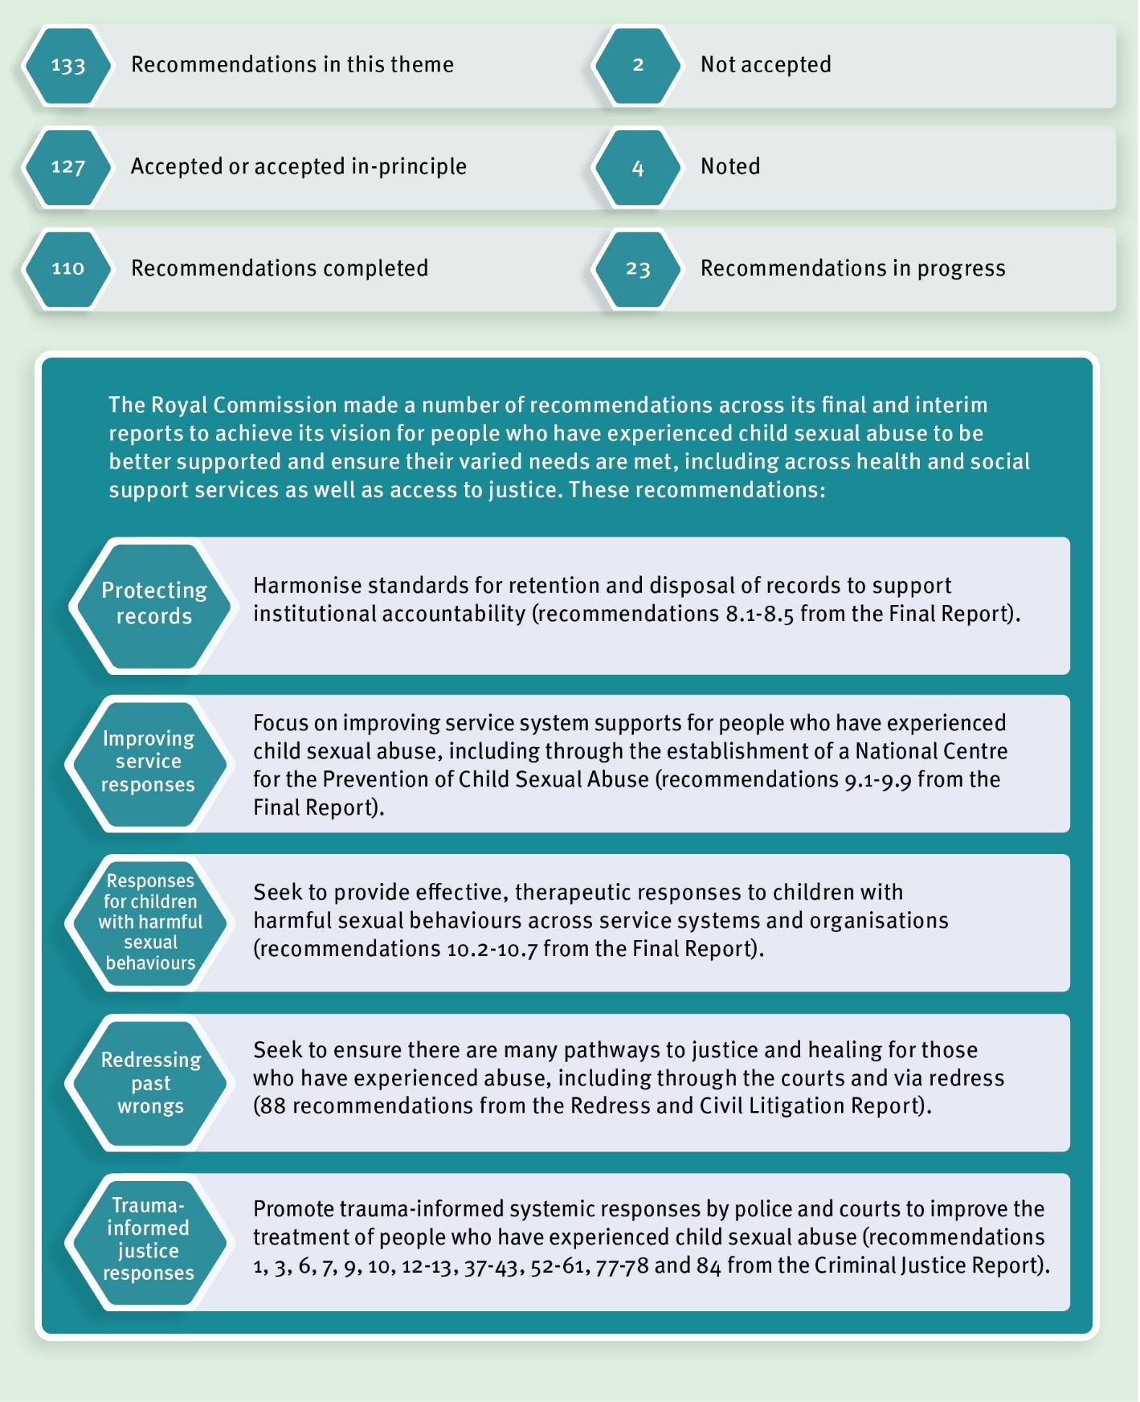

## Our progress

##### *Healing with Aboriginal and Torres Strait Islander peoples*

The Royal Commission found that for Aboriginal and Torres Strait Islander peoples the historical legacy of colonisation further compounds past and contemporary experiences of child sexual abuse in institutions.

In response to the historical legacy of colonisation, the Queensland Government has committed to reframing the relationship with Aboriginal and Torres Strait Islander Queenslanders in partnership with First Nations people, families and communities.

In August 2022, we launched the Queensland Government’s response to recommendations made by the Treaty Advancement Committee and confirmed the next steps on the Path to Treaty. We have established an Independent Interim Body to undertake local level truth telling together with public institutions such as libraries, councils and museums.

A formal Truth Telling and Healing Inquiry will be established to hear and chronicle the experiences of Aboriginal and Torres Strait Islander peoples in Queensland, including those who are survivors of child sexual abuse. These initiatives represent a major investment in healing and reconciliation in Queensland.

##### *Participating in the National Redress Scheme*

The Queensland Government maintains our commitment to ensuring people with lived experience of institutional child sexual abuse have access to justice and healing through the National Redress Scheme for people who have experienced institutional child sexual abuse (National Redress Scheme).

The Queensland Government joined the National Redress Scheme on 19 November 2018. Since then, until 31 December 2022, 2,396 applications have been finalised, with a determination that a Queensland Government agency or entity was responsible for the sexual abuse. Nationally, as at 31 December 2022, 10,893 applications had been finalised, with 10,453 payments totalling $919.4 million.

The Department of Child Safety, Seniors and Disability Services continues to work with the Federal Government and states and territories on ways to improve the operation of the National Redress Scheme. This included the implementation of relevant recommendations from the second-year review of the National Redress Scheme, which was released in 2021.

Work with non-government institutions to encourage their participation in the National Redress Scheme also continued. We remain dedicated to ensuring non-government organisations commit to joining the National Redress Scheme and to supporting other initiatives that ensure as many eligible Queenslanders as possible have access to redress.

As a participating institution, the Queensland Government is responsible for delivering direct personal responses to redress applicants who choose to receive one. This is a solemn responsibility, and we make every effort to ensure this is as meaningful and sensitive as possible.

Under the National Redress Scheme, state and territory governments are responsible for the counselling and psychological care element of redress. The Queensland Government continues to facilitate access to counselling and psychological care for redress applicants.

Information about the National Redress Scheme can be found here: National Redress Scheme | Community support | Queensland Government (www.qld.gov.au).

### Sexual violence prevention and support for people with lived experience

As mentioned earlier in this report, the 10-year *National Strategy to Prevent and Respond to Child Sexual Abuse* (National Strategy) includes a dedicated focus on supporting and empowering people with lived experience and enhancing a national approach to children with harmful sexual behaviours. The Queensland Government will continue to work with the Federal Government and states and territories on national initiatives to support people with lived experience.

##### *Responding to people with lived experience*

*Prevent. Support. Believe. Queensland’s Framework to address Sexual Violence* (Framework) is Queensland’s overarching approach to preventing and responding to sexual violence, including child sexual abuse. To support implementation of the Framework, a comprehensive whole-of-government action plan to address sexual violence was released in October 2021. The first *Prevent. Support. Believe. Queensland’s framework to address sexual violence—Action plan 2021–22* (Action Plan) outlines new and continuing sexual violence prevention and response actions across the Queensland Government.

To date, key achievements from the Action Plan include:

* a review of the Respectful Relationships Education Program to strengthen understandings of consent, help-seeking strategies, the drivers of gender-based violence and reporting of sexual assault and harm;
* continued collaboration through national forums to implement relevant recommendations of the Respect@Work report; and
* statewide implementation of the Queensland Police Service sexual violence liaison officer model.

##### *Responding to children with harmful sexual behaviours*

The Department of Child Safety, Seniors and Disability Services together with Queensland Health continue to work with the Federal Government and state and territory governments on developing a public health framework to prevent and respond to children with harmful sexual behaviours. A National Clinical Reference Group has been established to inform this work.

In 2018, the $12 million Youth Sexual Violence and Abuse initiative commenced in Queensland. This four-year initiative has now received additional funding from the Department of Justice and Attorney-General to extend it into 2023 and 2024.

This initiative includes three place-based projects in Toowoomba, Bundaberg and Yarrabah to work with young people (12-25 years) and communities to design and implement action plans to respond locally to youth sexual violence and abuse, including young people (12-25 years) with harmful sexual behaviours. The Queensland Government has provided an additional $1.8 million to continue the projects over the next two years from 2022-2024.

Community engagement and co-design is central to the projects. There was strong community input into the action plans, with over 300 people in Toowoomba (including 102 young people) and over 250 people in Bundaberg (including 77 young people) contributing innovative ideas for local prevention strategies. With co-design completed in late 2021, the focus now turns to implementation and evaluating the action plans over the next 18 months.

The Yarrabah project involves a partnership between the Yarrabah community, the Department of Justice and Attorney-General and the Department of Treaty, Aboriginal and Torres Strait Islander Partnerships, Communities and the Arts. The project is underpinned by a community-led approach that promotes self-determination, local ownership, local leadership and community-driven change.

As there is limited evidence on what constitutes best practice for sexual violence prevention, especially for Aboriginal and Torres Strait Islander communities, this project provides an opportunity to address this gap by working with the Yarrabah community to co-design a strengths-based prevention response informed by Aboriginal and Torres Strait Islander leadership, culture, country and community. Initial planning and community engagement commenced in October 2021. A project governance group of local organisations that work closely with Yarrabah’s young people is providing community oversight for the project. A young people’s project committee will also be established in early 2023 to ensure a youth-led approach. The co-design process, starting in early 2023, will be culturally safe and driven by the community.

The Youth Sexual Violence and Abuse initiative also includes $7.7 million in funding for youth sexual violence and abuse support services for children and young people in five locations, including Gladstone, Caboolture, Toowoomba, Rockhampton and South Burnett. The Queensland Government has allocated an additional $2.2 million to continue these services in 2022-23. These services provide trauma-informed counselling for young people who have experienced sexual violence and an early intervention response for young people with harmful sexual behaviours.

As part of an evaluation aspect of the initiative, the Swinburne University of Technology has assessed how youth sexual violence and abuse support services have been operating. The results from this assessment will be used to improve how these services are delivered to young people.

### Snapshot of trauma-informed service delivery across Queensland Government agencies

Many people with lived experience who came forward to the Royal Commission described difficulties in accessing mainstream services. The Royal Commission saw trauma-informed approaches as an emerging but promising practice to address these difficulties by making mainstream services more sensitive to the needs of people with lived experience.

Although we completed the Royal Commission’s recommendation (Final Report, recommendation 9.8) in 2020, Queensland Government agencies responsible for the delivery of human services continue to implement trauma-informed approaches including:

* Embedding trauma-informed approaches into the truth telling process as a key consideration as Queensland continues the Path to Treaty.
* Actively participating in national discussions about the work plan of the National Centre for Action on Child Sexual Abuse (National Centre). The National Centre was established to increase understanding of child sexual abuse and guide best practice responses and pathways for healing for people with lived experience.
* The Department of Education released a new online course on trauma-informed practice to assist school staff to respond to students who have experienced trauma in January 2023.
* Queensland Health’s First Nations equity reform agenda being the foundation for sustained and improved health outcomes for Aboriginal and Torres Strait Islander peoples. It is described as ‘our people in the system plus our voice in the system equals a better and more coordinated system’. In practical terms, this means partnering with Aboriginal and Torres Strait Islander peoples and organisations. Through these partnerships, First Nations-led models of service delivery will be embedded in the system, enabling Aboriginal and Torres Strait Islander peoples to access a holistic, culturally safe, trauma-informed, responsive healthcare system that is free from racism.
* Queensland Health’s *Aboriginal and Torres Strait Islander Mental Health Strategy 2016-21* supports a range of culturally safe, trauma-informed mental health, alcohol, and other drug services for Aboriginal and Torres Strait Islander peoples. Queensland Health’s Mental Health Community Support Services program continues to deliver support to Aboriginal and Torres Strait Islander peoples experiencing moderate to severe mental illness.
* Queensland Health’s *Suicide Prevention Practice Guideline*, published in October 2021, assists clinical teams within mental health, alcohol, and other drug services to embed best practice approaches.
* Queensland Health’s *Mental health intensive care in acute mental health units* guideline published in July 2022 provides best practice recommendations for delivering trauma-informed care to consumers of Queensland Health services including children and adolescents.
* In 2019-20, the Queensland Government invested $80.1 million to support implementation of Queensland Health’s *Every Life: Queensland Suicide Prevention Plan 2019-2029*, delivery of which has continued throughout 2022.
* Queensland Health released the *Optimising Adolescent and Young Adult Care in Queensland Strategy 2022–2027* to improve care and outcomes for young people.
* The Queensland Government’s 2022-23 State Budget provides more than $305 million for new community and bed-based mental health initiatives for children, adolescents, and young people under the Queensland Health’s Better Care Together program.
* Queensland Corrective Services continues to provide professional development activities to psychologists and counsellors to enhance their therapeutic practice when working with people who have experienced trauma. These professional development activities are facilitated by external agencies that are considered leaders in the field of trauma support and intervention.
* Queensland Corrective Services received $2.9 million in the 2022-23 State Budget to increase psychological support services in Queensland correctional centres.
* Ensuring trauma-informed practice is paramount in youth detention centres as many young people in the youth justice system have experienced trauma. Youth detention centres are subject to a continuous policy and procedure review cycle to ensure the operation of centres are based on evidence and contemporary best practice including trauma-informed approaches.
* The *Hope and Healing framework for residential care* and *Hope and Healing for foster care* supports trauma-informed responses to children in care who have experienced trauma, abuse and neglect.
* Services funded as part of the Youth Sexual Violence and Abuse initiative also provide training and mentoring to strengthen capacity of professionals to recognise and respond appropriately to young people with harmful sexual behaviours.

##### *Trauma informed criminal justice responses by police*

For many people, a criminal justice response to child sexual abuse or sexual assault commences with the decision to make a report to police. As this can be a difficult decision, officers from the Queensland Police Service, including specialist officers, are available to talk with people with lived experience about their decision, regardless of when the abuse took place. As previously mentioned in this report, there is a range of reporting options available, including online reporting.

In 2021, the first *Queensland Police Service* *Sexual Violence Response Strategy 2021-2023* (the Strategy) was published. A key focus of the Strategy is promoting a victim-centric and trauma-informed response to people with lived experience. As the Strategy commits police to continuous improvement in responses to people with lived experience of sexual violence, we are completing recommendation 12 of the Criminal Justice Report in 2022.

Building on the Strategy, the Queensland Police Service is strengthening its response to sexual violence through:

* The statewide roll-out of Sexual Violence Liaison Officers. Commencing in January 2022, the role of these officers includes liaising with local sexual assault support services to promote the participation of support people as well as ensuring accurate and consistent communication is provided to all people who report sexual violence to police.
* Releasing the first two products in a suite of specialist training, including *Child Sexual Abuse Fundamentals Education and Challenging Beliefs, Inferences, Attitudes and Stereotypes*. The content of these courses includes understanding institutional child sexual abuse and trauma, child development, bias and decision-making and understanding stress.

Feedback from the participants of the training program describes how learning about childhood trauma has helped police understand the impact of child sexual abuse on the behaviour and interactions of people with lived experience. As a result of the training, participants expressed a determination to change their approach and communication style and focus on the positive impact the police can have helping people with lived experience.

People with disability are particularly vulnerable to sexual abuse and exploitation. The Queensland Police Service partnered with WWILD to raise awareness of sexual assault support and reporting among women with an intellectual or learning disability. A senior police investigator was featured in an episode of WWILD’s podcast, *And You Think You’re the Expert*, talking about how police can better support, communicate and respond to women with intellectual disability who have experienced sexual violence.

##### *Trauma informed prosecutions*

In our 2018 Queensland Government response, our position on recommendations relating to the Director of Public Prosecutions was ‘For Further Consideration’. These recommendations involve principles for the prosecution of child sexual abuse offences including charge and plea decisions (Criminal Justice Report, recommendations 37 and 38) and the development of material for complainants and witnesses to better inform them about giving evidence (Criminal Justice Report, recommendation 38).

Following further consideration of these recommendations, we have changed our position to ‘Accept’ because the intent of the recommendations has been met through exiting procedures, guidelines, and arrangements. This includes:

* Responses by the Office of the Director of Public Prosecutions to child sexual abuse are guided by the Royal Commission’s recommended principles including charge and plea decisions. The Directors’ Guidelines allow for complainants to request written responses for key decisions, where reasonably practicable.
* The Office of the Director of Public Prosecutions has developed and provides comprehensive information to complainants. This includes fact sheets on a variety of aspects of the criminal justice experience relating to court processes, information about sexual offences, pre-recording evidence of child witnesses and giving evidence as a special witness.
* Victims Assist Queensland publishes *A guide for victims of crime in Queensland* which is available online.
* Additional Victim Liaison Officers were recruited in 2020 to facilitate regular communication with, and updating of, complainants.
* The Queensland Government funds witness assistance services provided by non- government organisations such as Protect All Children Today to keep complainants and their families informed and connected to relevant support services.

##### *Women’s Safety and Justice Taskforce*

As previously mentioned in this report, several recommendations by the Royal Commission in its Criminal Justice Report, which form part of this theme (*Theme 3: Healing and Support*), will be progressed as part of implementation of the Women’s Safety and Justice Taskforce’s recommendations including recommendations to:

* establish formal complaints mechanisms and internal audit processes within the Director of Public Prosecutions (recommendations 41–43);
* allow for pre-recording of evidence and audio-visual recording of evidence (recommendations 53, 56 and 57); and
* facilitate special measures for complainants and vulnerable witnesses including giving evidence via closed circuit television or audio-visual link; being supported by a support person or support animal; and creating a more child-friendly environment (recommendation 61).

With the Queensland Government supporting, or supporting in principle, these recommendations as part of our response to the Women’s Safety and Justice Taskforce, our position these recommendations has moved from ‘For Further Consideration’ to ‘Accept in Principle’.

In addition, we will work on recommendation 60 of the Criminal Justice Report in the context of Women’s Safety and Justice Taskforce implementation. This recommendation aims to ensure that ground rules hearings are held in child sexual abuse prosecutions to discuss the questioning of witnesses with specific communication needs, whether the questioning is to take place via a pre-recorded hearing or during the trial.

##### *Queensland’s pilot intermediary scheme*

The Queensland Intermediary Scheme Pilot Program formally commenced in Brisbane and Cairns regions on 5 July 2021 as a two-year pilot program. The scheme has been developed by the Department of Justice and Attorney-General, with the participation of stakeholders from the Queensland Police Service, Office of the Director of Public Prosecutions, Defence Counsel, and the Judiciary. It responds to recommendations 59 and 60 of the Royal Commission’s Criminal Justice Report.

In Queensland, intermediaries are qualified speech pathologists, occupational therapists, psychologists, and social workers who assist police and the courts to obtain the best evidence from vulnerable prosecution witnesses in child sexual offence matters. Intermediaries assess the witness’ communication needs and provide practical advice on the best ways to question and communicate with the witness.

The Queensland Intermediary Scheme Pilot Program will continue until 30 June 2023. Evaluation of the pilot is underway and being led by the Australian Catholic University with a consortium of researchers. The final evaluation report is due in late October.

### Keeping the spotlight on record keeping

In our 2020 annual progress report, we highlighted as one of our achievements the release of the *Guideline on creating and keeping records for the proactive protection of vulnerable persons* (guideline) and accompanying disposal authorisations by the Queensland State Archives. The guideline was developed in response to Final Report recommendations 8.1–8.4 and in recognition of the Royal Commission’s findings that poor recordkeeping has contributed to the failures of institutions to identify and respond to child sexual abuse and has exacerbated distress and trauma for many people with lived experience.

The guideline highlights the responsibility of institutions to identify and mitigate the risk to vulnerable persons, including children, from all forms of abuse. The guideline and disposal authorisations apply to all Queensland public authorities.

The Queensland State Archives, in consultation with the Department of Education, updated the dedicated *Vulnerable Persons* webpage to assist non-state schools meet the same standards applicable to government schools in relation to records relevant to child safety and wellbeing, including child sexual abuse. The *Vulnerable Persons* webpage hosts a range of best practice record-keeping resources, as well as resources that explore the Royal Commission and its recommendations. The update to Queensland State Archive’s Vulnerable Persons webpage went live on 21 November 2022. The Department of Education will communicate this update to non-government schools to increase awareness about advice from the Queensland State Archives.

As part of the Department of Education’s broader program to ensure that the regulatory framework for non-state schools reflects contemporary practice and meets community expectations, it is continuing to explore additional strategies to strengthen non-state school recordkeeping requirements while implementing other Royal Commission recommendations such as child safe standards. With this work underway, we have changed our position on recommendations 8.5 from ‘For Further Consideration’ to ‘Accept in Principle’.

In addition, Queensland State Archives is working with the Department of Education to review the Education and Training Sector retention and disposal schedule. The purpose of the review is to include additional disposal authorisations relating to vulnerable persons into the schedule, with the review expected to be completed in early 2023. The Education and Training Sector retention and disposal schedule applies to early childhood education and care, schools (including primary and secondary state schools, grammar schools and other schools established under an Act), TAFE Queensland and other Registered Training Organisations established under an Act and the non-State Schools Accreditation Board.

## Looking forward

From 2023, the Queensland Government will continue our work to support healing and assist people with lived experience by:

* continuing on the Path to Treaty in Queensland, including both formal and local level truth telling processes;
* continuing our participation in the National Redress Scheme;
* implementing recommendations from the Women’s Safety and Justice Taskforce; and
* continuing the Queensland Intermediary Scheme pilot program.

# Information about support services

There are support services available to those who need assistance. If immediate assistance is required, 24-hour support is available through:

* **Kids Helpline:** 1800 55 1800
* **Lifeline:** 13 11 14
* **1800 Respect:** 1800 737 732
* **MensLine Australia:** 1300 789 978

**Lotus Place** is a dedicated support service and resource centre for Forgotten Australians and can be contacted via phone on 3347 8500. For more information, please visit the Lotus Place website [www.lotusplace.org.au.](http://www.lotusplace.org.au/)

Free legal advice and information about the justice or redress pathways available to survivors of institutional child sexual abuse can be accessed through **knowmore Legal Services**, on 1800 605 762. For more information, please visit the knowmore website [www.knowmore.org.au.](http://www.knowmore.org.au/)

Further advice and resources for support regarding child sexual abuse can be found online by visiting [www.qld.gov.au/community/getting-support-health-social-issue/](http://www.qld.gov.au/community/getting-support-health-social-issue/) support-victims-abuse/child-abuse/child-sexual-abuse/child-sexual-abuse-help.

1.