Statement on the use of restrictive practices for an adult with cognitive/intellectual disability
Background information
In 2014, the Queensland parliament approved changes to the Disability Services Act 2006 and the Guardianship and Administration Act 2000. One of the amendments to the Disability Services Act 2006 is the requirement for service providers to give a statement about the use of restrictive practices to the adult. The information to be provided in the statement includes:
- why a restrictive practice is being considered for the person
- how the person can be involved and express their views
- who decides whether the restrictive practices will be used
- how to make a complaint or seek a review of a restrictive practice.
The service provider must explain the statement to the adult in the way they are most likely to understand.

How to use this tool:
- This is the approved format of the model statement for an adult with intellectual disability. It provides the basis of the information that needs to be discussed with the person as per the legislation.
- Information in the statement will need to be personalised for the person depending on their communication skills and their individual situation. For example:
  - where you see ……….write down the name or provide a photo of the relevant person
  - for words such as ‘support worker’ and ‘restrictive practices’ use words that are most commonly used by the adult.
- The statement should not just be given to the adult; it is important that someone sits with them and discusses the information. This discussion is how the information can be individualised for the person. Sometimes you may need to do this over a couple of conversations.
- Use a variety of different visual tools to support this discussion and personalise the information for the person. When discussing the statement, use supporting visual tools of Positive behaviour support - model statement information story and Positive behaviour support—model statement visual tool to individualise this and discuss it in a meaningful way with the person.
- It is still important to gain information from the person about their views and how they feel while you are discussing the topic with them. In order to do this:
  - ensure that any tools that the person uses to communicate their message are present when discussing the information and encourage the person to use them
  - when discussing the model statement remember to build in opportunities to allow the person to share their views, e.g., pausing, asking questions, etc.
  - consider how to record this information.
- Involve other people who are important to the person, e.g., family and friends.
Note for Communication partners:
This information will need to be personalised for the adult.

When discussing the statement use supporting visual tools of ‘Positive behaviour support - model statement information story’ and Positive behaviour support—model statement visual tool to individualise this and discuss it in a meaningful way with the person.
Where you see ……………., add information relevant to the person. Consider using photos.

Statement of Use of Restrictive Practices

Support workers help to keep you and other people safe.

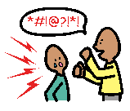
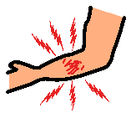
Sometimes you might do things that are not safe. You might:
- hurt yourself,
- hurt other people.

Support workers may keep you safe using restrictive practices*. When you are safe the restrictive practices* will stop.

……………………………. is writing a plan.

The plan will tell support workers how to help you when you do things that are not safe.

* Use visual tools to explain this term in a way that is meaningful for the person and is specific for their situation and the restrictive practice/s
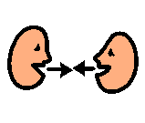

……………………….. will ask you how support workers can help you. They will also talk to your family and support workers.

They will write down how support workers can help you in the plan.

Your support workers must read the plan so they know how to help you. They will help you in the same way.


………………………….. will say the plan is ok.

It is important to keep you safe.

Your support workers must tell the department when they use restrictive practices*. This will help keep you safe.

* Use visual tools to explain this term in a way that is meaningful for the person and is specific for their situation and the restrictive practice/s

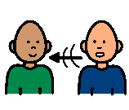
A complaint is when you are not happy and you tell someone.

It is ok to make a complaint.
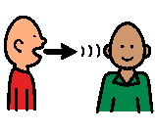
You can complain to a support worker, your family or ………………………. if you are not happy with your plan.
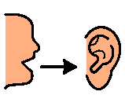
They will listen to you.

Version 3- Gazetted July 2015. Updated June 2022.

