**I**

**A Wellbeing Outcomes**

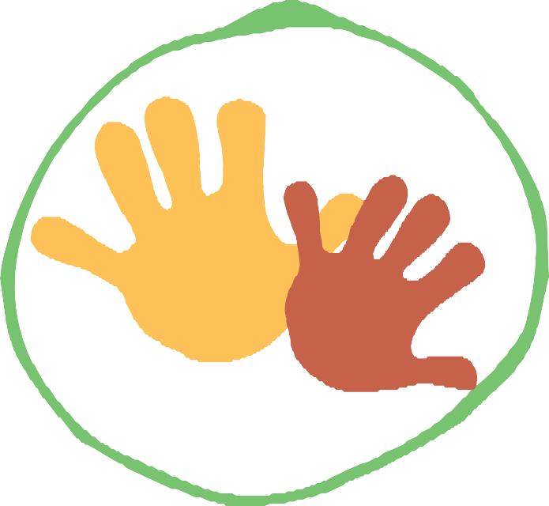

**Framework for Aboriginal and Torres Strait Islander children and young people in Queensland**

**November 2019**

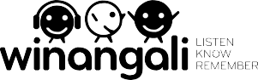 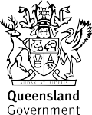



# We respectfully acknowledge the First Nations people in the State of Queensland; we acknowledge the cultural and spiritual connection that Aboriginal and Torres Strait Islander peoples have with the land and sea.

**We respectfully acknowledge Aboriginal people and Torres Strait Islander people as two unique and diverse peoples with their own rich and distinct cultures.**

**We pay our respects to Elders past and present as well as the existing and emerging leaders who walk together in partnership on this journey.**

Winangali was commissioned by the Queensland Government to develop the Wellbeing Outcomes Framework.

**Table of Contents**

Part A: Introduction 2

Setting the context for the Wellbeing Outcomes Framework for Aboriginal and

Torres Strait Islander children and young people in Queensland 2

What is the Wellbeing Outcomes Framework? 2

What does the Framework contain? 2

What will the Framework achieve? 3

How was the Framework developed? 3

How should the Framework be used? 4

Part B: The Framework 5

How to define and measure wellbeing for Aboriginal and Torres Strait Islander

children and young people in Queensland 5

Who are children and young people? 5

What is wellbeing for Aboriginal and Torres Strait Islander children and young people? 5

Wellbeing Outcomes Framework: an overview 6

Culture and Connection 9

Economic Empowerment 11

Health 12

Mental Health and Emotional Wellbeing 13

Learning and Skills 14

Home and Environment 15

Empowerment 16

Safety 18

References 20

1

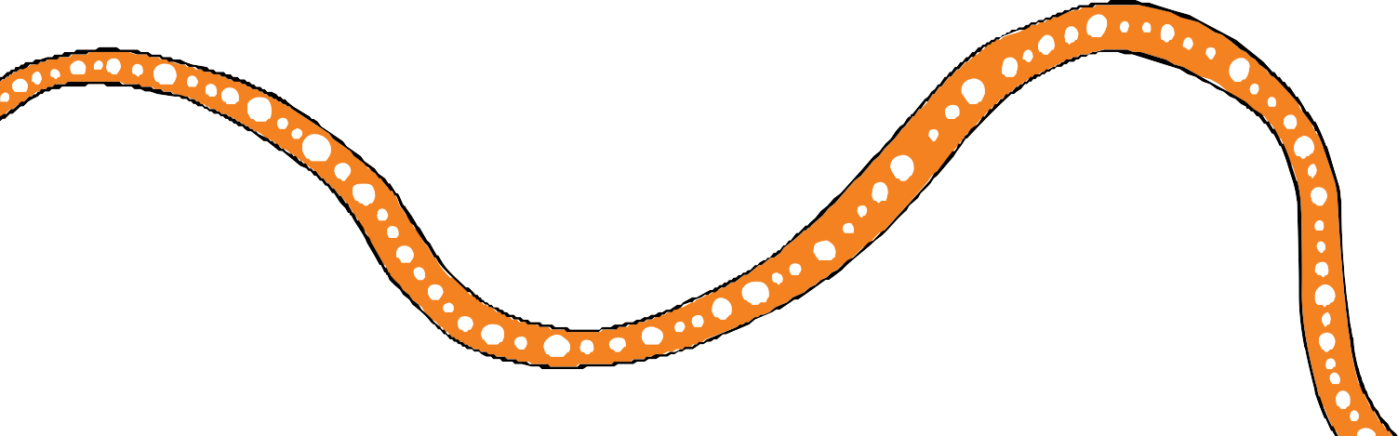

**Part A: Introduction**

# Setting the context for the Wellbeing Outcomes Framework for Aboriginal and Torres Strait Islander children and young people in Queensland

# What is the Wellbeing Outcomes Framework?

The Wellbeing Outcomes Framework for Aboriginal and Torres Strait Islander children and young people in Queensland outlines the aspirations that Aboriginal and Torres Strait Islander families and communities and the Queensland Government have for the wellbeing of Aboriginal and Torres Strait Islander children to thrive and grow up safe, connected to community and culture.

The Framework is the first of its kind. It defines wellbeing and how it will be measured for Aboriginal and Torres Strait Islander children and young people in Queensland.

The Framework identifies outcomes that support Aboriginal and Torres Strait Islander peoples’ positive aspirations for their futures – to ensure Aboriginal and Torres Strait Islander children and young people have all the opportunity and support to live their best, most fulfilled lives.

As a strategic document, the Framework aligns with and supports the whole-of-government objectives and commitments outlined in *Our Future State: Advancing Queensland’s Priorities*1 and *Our Way: A generational strategy for Aboriginal and Torres Strait Islander children and families*2 (Our Way).

The Framework does not prescribe how agencies should apply it or what programs and services should receive investment.

# What does the Framework contain?

From the perspective of Aboriginal and Torres Strait Islander Queenslanders who were consulted during the development of this Framework, this document:

* defines wellbeing for their children and young people
* identifies the outcomes that should be sought to achieve wellbeing for their children and young people and how these outcomes should be measured
* explains the responsibility held by ‘adult institutions’ to help fulfil children and young people’s wellbeing.

2

# What will the Framework achieve?

The Framework aims to:

* inform whole-of-government and agency policy development and decision making to improve outcomes for Aboriginal and Torres Strait Islander children, youth and families
* guide service delivery efforts by government-funded providers
* assist communities to identify areas of focus
* provide a clear set of outcomes against which Our Way, and its implementation, can be evaluated
* define wellbeing for Aboriginal and Torres Strait Islander Queenslanders broadly and children and young people specifically.

# How was the Framework developed?

The development of a Wellbeing Outcomes Framework for Aboriginal and Torres Strait Islander children and young people was identifi in Our Way and its fi st implementation plan — *Changing Tracks: An action plan for Aboriginal and Torres Strait Islander children and families 2017–19*3 (Changing Tracks). Both Our Way and Changing Tracks highlighted the need for achievement of outcomes for Aboriginal and Torres Strait Islander children, youth and families in Queensland to be seen through a different lens — a lens that sees not only the things that need to change

(e.g. eliminate the disproportionate representation of Aboriginal and Torres Strait Islander children in the child protection system) but also the things that need to be nurtured (e.g. Aboriginal and Torres Strait Islander peoples’ positive aspirations for their lives). This Wellbeing Outcomes Framework aims to achieve this new, strengths-based perspective.

The following activities were undertaken to develop this Framework:

* mapping of current Queensland Government strategies, frameworks, plans and programs that aim to improve outcomes for Aboriginal and Torres Strait Islander peoples
* desktop review of existing wellbeing outcomes frameworks both domestic and international
* consultation with Aboriginal and Torres Strait Islander communities, organisations and young people
* consultation with the Queensland First Children and Families Board
* consultation with government stakeholders.

The findings and insights from all of these activities have informed the content of this Framework, with preference being given to Aboriginal and Torres Strait Islander peoples’ views on wellbeing, the domains that make up wellbeing and what the wellbeing outcomes look like.

3

# How should the Framework be used?

The Framework is intended to be used by:

* + Queensland Government agencies to inform policy development and investment decisions
  + Queensland Government to inform the Closing the Gap refresh negotiations, monitoring and reporting
  + service providers to inform service design and delivery
  + communities to advocate for policy reform as well as to develop community-led initiatives that enable wellbeing.

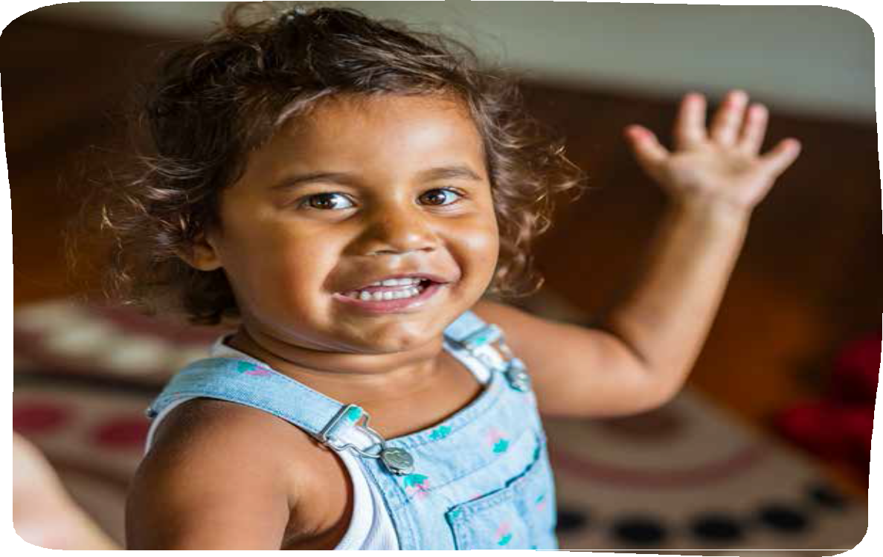

4

**Part B: The Framework**

# How to define and measure wellbeing for Aboriginal and Torres Strait Islander children and young people in Queensland.

# Who are children and young people?

The Framework defines children and young people as all Aboriginal and Torres Strait Islander children and young people, including an unborn child to a young person 25 years of age.

# What is wellbeing for Aboriginal and Torres Strait Islander children and young people?

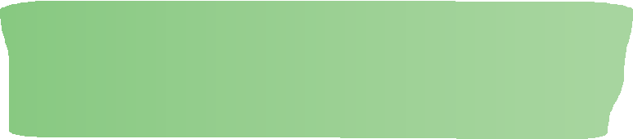

*“A child needs to feel like they have a future.”*

Community consultation participant, Brisbane

*“Wellbeing means you have good people to learn off.”*

Community consultation participant, Mt Isa

Wellbeing is a complex synthesis of factors that influence happiness or satisfaction within our lives.4 It can be highly individual and subjective, with different meanings for different people, and can change across the life course.5 Wellbeing is a product of many, often interrelated factors.6

Wellbeing for Aboriginal and Torres Strait Islander peoples incorporates broader issues of social justice, equity and human rights. The significance of culture to wellbeing, and therefore good health, is also demonstrated by using traditional knowledge and the practices of traditional healers, which are adapted by many people to complement western science in an integrated health care system.7 Connection to spirituality, land and culture is also seen as an integral and unique component of Indigenous concepts of wellbeing.8

During the consultations on the Framework, Aboriginal and Torres Strait Islander Queenslanders defi wellbeing for children and young people as holistic and including social, emotional, economic, and cultural wellbeing that flourishes in an environment of discipline, structure and boundaries.

Wellbeing of children and young people is inextricably linked to the wellbeing of the family and community. Having healthy families and safe communities, leads to healthy and safe children.

The adult institutions in a child’s life — parents, family, service providers, and government — play critical roles in their wellbeing.

A safe and loving environment which supports teaching of culture is also essential. In this sense wellbeing for children and young people means a loving, supportive family, safe and healthy homes, structure and routine, a positive and transformative education, nutritious food, warmth and strong connection to culture and land.

Ultimately, wellbeing means that Aboriginal and Torres Strait Islander children and young people can live their best life. Children are able to be children. Young people can be young people. They can have hopes and dreams and have the best start in all aspects of their life to fulfil those hopes and dreams.

5

**I**

Our children are strong in culture

Our children learn, develop and thrive

# Wellbeing Outcomes Framework: an overview

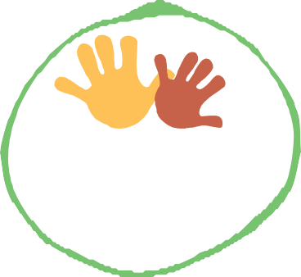

**CULTURE**

**AND CONNECTION**

**SAFETY**

**ECONOMIC**

**EMPOWERMENT**

**EMPOWERMENT** Our children are heard

Our children are strong

and healthy

**HEALTH**

**Aboriginal and Torres**

**Strait Islander children and young people wellbeing**

**HOME**

**AND ENVIRONMENT**

**MENTAL**

**HEALTH AND EMOTIONAL WELLBEING**

**LEARNING**

**AND SKILLS**

6

The diagram captures the key aspects of wellbeing for Aboriginal and Torres Strait Islander children and young people as identified from the literature review and confirmed through consultations. The key components of this diagram are as follows:

**A rights-based environment** that enables wellbeing to be fulfilled by upholding the best interests of the child, as articulated in the Queensland *Human Rights Act 2019*9, is imperative. The United Nations Convention on the Rights of the Child10 (CROC) and the United Nations Declaration on

the Rights of Indigenous Peoples11 (UNDRIP) provide other important lenses through which to view wellbeing for Aboriginal and Torres Strait Islander children and young people. Together, the *Human Rights Act 2019*, CROC and UNDRIP provide the enabling, rights framework for the best interests of the child to be upheld and their wellbeing to flourish.

**Eight interconnected wellbeing domains** represent all the areas of a child and young person’s life that impact on their wellbeing. In this diagram, all domains are equally important. This framework captures the following wellbeing domains:

* Culture and Connection
* Economic Empowerment
* Health
* Mental Health and Emotional Wellbeing
* Learning and Skills
* Home and Environment
* Empowerment
* Safety

**Wellbeing outcomes** are attached to each domain. Each outcome represents the ultimate state of wellbeing for children and young people for a particular domain. For example, regarding

the Mental Health and Emotional Wellbeing domain the ultimate outcome is that ‘Children are hopeful’. To illustrate the relationship between the domain, outcome and child’s wellbeing, each outcome extends from the domain to the child and young person at the centre of the diagram.

**Indicators** included in the Framework are some of a range of indicators for success against which actions and initiatives intended to improve outcomes for Aboriginal and Torres Strait Islander children and young people may be measured. During the application of the Wellbeing Outcomes Framework, indicators will be refined to reflect agencies portfolio responsibilities.

**Kin, culture and country** is a concept that emerged in the consultations as being the primary protective factor and enabler for Aboriginal and Torres Strait Islander children and young people. Like a sheath that wraps around children at the centre, connection to kin, country and culture must exist for wellbeing to exist.

**Adult institutions** refers to the three circles that surround Aboriginal and Torres Strait Islander children and young people. The purpose of capturing these adult institutions is to recognise the fact that adults have the greatest influence over children and young people’s wellbeing, especially before they move into young adulthood (i.e. from 18 years of age).

7

The fi st and most influential adult institution is that of a child and young person’s direct carers — their parents, kin and non-parent carers. On a daily basis, from their child’s birth, parents make decisions that either positively or negatively affect their children’s lives. It is hoped this Framework helps parents to see what role they must play in ensuring the wellbeing of their children.

The second adult institution is that of the services that a child or young person may access throughout the course of their lives. Such services include school, medical, sports and recreation. It also incorporates the community in which they grow up. Both services and communities must support children’s wellbeing. They must embrace children and young people’s needs, celebrate their culture and identities, and create environments where children and young people can flourish and have access to opportunity.

The third adult institution is that of government. Government is responsible for enabling wellbeing through the legislation and policies it creates as well as the programs it invests in.

The above elements combine to enable the wellbeing of Aboriginal and Torres Strait Islander children and young people.

The next section discusses in detail each domain, related outcome and related indicators for measurement.

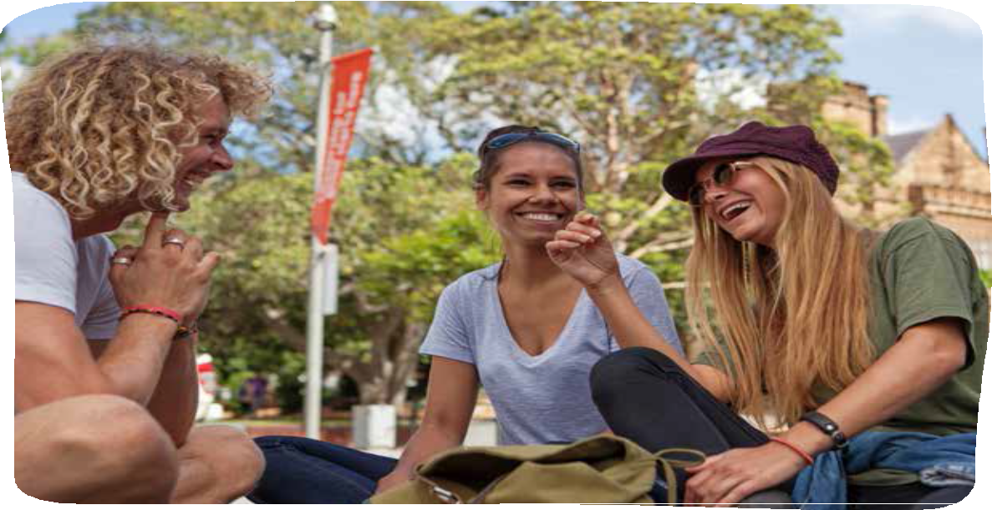

8

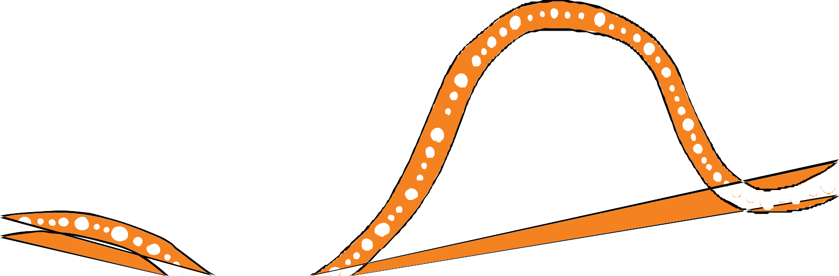

**Culture and Connection**

## Definition

Culture and Connection refers to all the elements that form a child’s sense of identity and pride in their identity as an Aboriginal and Torres Strait Islander person. This includes:

* knowledge and practice of culture, language, stories and tradition
* understanding contemporary history and its ongoing impacts
* recognition of and respect for Aboriginal and Torres Strait Islander cultures
* having a sense of spirituality born out of a connection to country (land, waters and seas) and heritage
* belonging to family and community
* participating in broader society with freedom from discrimination.

Culture and Connection operates as a discrete domain while also being the lens through which the other domains are viewed.

## Why Culture and Connection is important



*“It is who we are and how we interact with each other and the world.”*

Community consultation participants, multiple locations.

Culture and Connection is important for the wellbeing of Aboriginal and Torres Strait Islander children and young people because, as one community member put it, ‘it is everything’. Strong cultural identity and connections are key protective factors for Aboriginal and Torres Strait Islander children and young people. This domain includes interactions in the home, with Elders and the community, with country, land and water. Those consulted felt that life-skills are rooted in culture and the connections made as an Aboriginal and Torres Strait Islander Queenslander.

9

The Queensland *Human Rights Act 2019* (s 28) states that Aboriginal and Torres Strait Islander peoples in Queensland hold distinct cultural rights. They include the rights to practice their beliefs and teachings, use their languages, protect and develop their kinship ties, and maintain their relationship with the lands, seas and waterways.

## Outcome

Our children are strong in culture.

## Indicators

* + Levels of participation in language and cultural practice
  + Level of knowledge of and pride in identity
  + Levels of access to and communal ownership of traditional lands, seas and waters
  + Rates of discrimination based on race
  + Level of recognition and celebration of Aboriginal and Torres Strait Islander cultures

The above indicators are indicative only and have been informed by similar indicators contained within New Zealand’s Child and Youth Strategy12, the Closing the Gap targets13, and the National Plan for Child and Youth Wellbeing.14

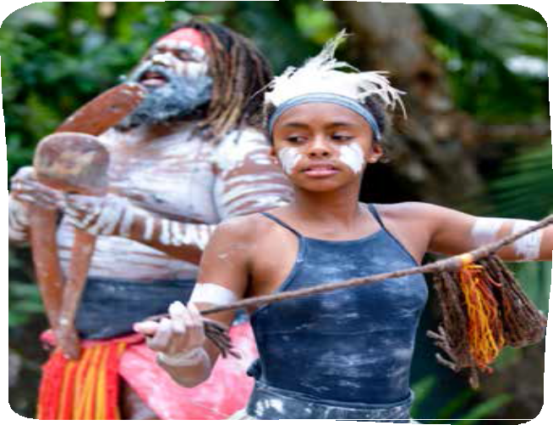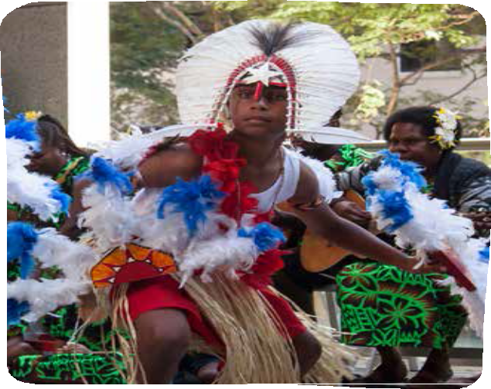

10

**Economic Empowerment**

## Definition

Economic Empowerment includes ensuring the environment that children grow up in is free from poverty, and where parents, carers and family have access to economic opportunity. It also

includes ensuring young people, once of working age, have access to employment and enterprise opportunities to enable them to be productive members of the community.

## Why Economic Empowerment is important



*“You have a future and plan for a future.”*

Community consultation participant, Ipswich

Economic Empowerment is important for the wellbeing of Aboriginal and Torres Strait Islander children and young people because it contributes to the safety and quality of life for Aboriginal and Torres Strait Islander peoples. It is an indicator that they have a range of opportunities available to them: educational, employment and recreational.

The Queensland *Human Rights Act 2019* (s 15) states that everyone is entitled to equal and effective protection against discrimination, and to enjoy their human rights without discrimination.

## Outcome

Our children have access to every opportunity.

## Indicators

* Level of youth and parental/carer job security
* Level of parental/carer employment
* Rates of youth in employment/training/education
* Household financial wealth
* Household net adjusted disposable income

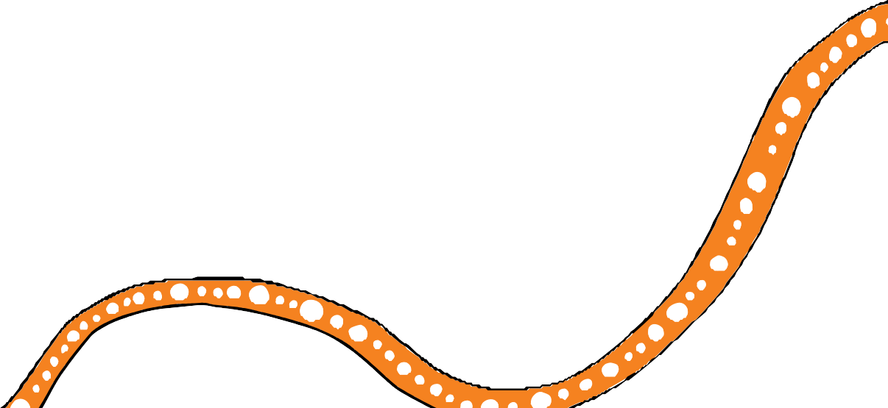

The above indicators are indicative only and have been informed by similar indicators contained within the Better Life Index15, the Closing the Gap targets16, and the National Plan for Child and Youth Wellbeing.17

11

**Health**

## Definition

Health refers to physical and spiritual health and their social determinants. This includes ensuring that children and young people have access to affordable and appropriate medical care as well as a healthy lifestyle from birth to adulthood. Maternal health — both antenatal and perinatal — is also critical for children’s own health, especially in the early years.

## Why Health is important

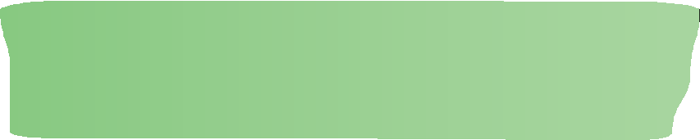

*“Aboriginal children have access to vaccinations, dental care... we are actively trying to close the gap and have*

*a population that have healthy bodies and minds.”*

Community consultation participant, Ipswich

Health is important for the wellbeing of Aboriginal and Torres Strait Islander children and young people. It informs whether First Nations Australians are moving out of poverty and into a good quality of life that improves access to services and life expectancy. A healthy body and a healthy mind will contribute to a good life and high confidence.

The Queensland *Human Rights Act 2019* (s 37) states everyone has the right to access health services without discrimination.

## Outcome

Our children are strong and healthy.

## Indicators

* + Life expectancy
  + Birthweights
  + Immunisation rates
  + Healthy physical development
  + Dental health
  + Maternal health
  + Parental mental health

The above indicators are indicative only and have been informed by similar indicators contained within the Better Life Index18, New Zealand’s Child and Youth Strategy19, the Closing the Gap targets20, and the National Plan for Child and Youth Wellbeing.21

12

**Mental Health and Emotional Wellbeing**

## Definition

Mental Health and Emotional Wellbeing incorporates promotion of resilience, hope for the future and positive body, mind and spirit. It also recognises many Aboriginal and Torres Strait Islander children and young people are dealing with grief and loss, the impacts of intergenerational trauma, violence and abuse. The consequences and symptoms of poor mental health are addressed by

this domain including anti-social behaviour, bullying, suicide and alcohol/substance misuse. Alongside education and health, Aboriginal and Torres Strait Islander parental mental health is another critical element of this domain.

## Why Mental Health and Emotional Wellbeing are important



*“If someone has mental health issues and is not getting assistance, then everything else in their life is really difficult.”*

Community consultation participant, Cairns

Mental Health and Emotional Wellbeing are important for the wellbeing of Aboriginal and Torres Strait Islander children and young people because they are more likely to experience trauma, grief and loss earlier in their lives and more frequently. This individual and community experience then impacts on mental health, emotional and physical wellbeing. Building resilience and having adequate mental health services are critical for addressing trauma, grief and loss and their impacts.

The Queensland *Human Rights Act 2019* (s 26) states that children are entitled to protection that is needed because they are a child and reasonable steps must be taken to ensure the physical safety if someone is in danger or at risk of physical harm.

## Outcome

Our children are hopeful.

## Indicators

* Level of parental wellbeing
* Rates of access to mental health services
* Rates of attempted suicide, suicide and self-harm
* Frequency and nature of help-seeking
* Time devoted to personal care
* Rates of alcohol and substance use
* Rates of participation in positive activities (e.g. sport and recreation, cultural practice)

The above indicators are indicative only and have been informed by similar indicators contained within the Better Life Index22 and New Zealand Child and Youth Strategy.23

13

**Learning and Skills**

## Definition

Learning and Skills refers to age-appropriate learning and development for all children and young people. The development of knowledge and skills includes those obtained through formal education as well as life skills. Ultimately all learning should enable children and young people to become healthy and resilient adults, as well as ensure they are ready for a life of education and work. To this extent early years development, educational attendance and attainment as well as maternal and paternal education are important factors. Passing on of cultural knowledge and practice, including language, is critical.

## Why Learning and Skills are important



*“Learning and Skills give us advancement and confidence.”*

Community consultation participant, Brisbane

Learning and Skills are important for the wellbeing of Aboriginal and Torres Strait Islander children and young people because they involve helping children and young people build the tools they need to live their best life. This includes age-appropriate social, physical and cognitive development, life skills, formal education and cultural knowledge.

The Queensland *Human Rights Act 2019* (s 36) states every child has the right to primary and secondary schooling and to vocational education based on their ability.

## Outcome

Our children learn, develop and thrive.

## Indicators

* + Levels of educational attainment and participation
  + Early childhood education participation (0–4 years)
  + Level of early childhood development
  + Level of parental engagement in child learning
  + Performance in English, Maths and Science (at Year 4 and Year 9)
  + Level of maternal and paternal educational attainment and participation

The above indicators are indicative only and have been informed by similar indicators contained within the Better Life Index24, New Zealand’s Child and Youth Strategy25, the Closing the Gap targets26, and the National Plan for Child and Youth Wellbeing.27

14

**Home and Environment**

## Definition

Home and Environment refers to children and young people having places to call home that are healthy, safe and secure. Places where children and young people sleep, eat, study and play, have the basics of a bed, food and shelter, while also being a place where they feel loved, secure and

connected. In this sense, for an Aboriginal and Torres Strait Islander child and young person, home can be multiple places — it can be with their parents, grandparents, aunts and uncles — and safety, love and connection follow the child to these various places. The quality of the environment where children and young people live, study, play — the water, air, pollution and sanitation — is also important.

## Why Home and Environment are important



*“It is our safe zone.”*

Community consultation participants, multiple locations

Home and Environment are important for the wellbeing of Aboriginal and Torres Strait Islander children and young people because they provide a sanctuary where culture and individuality are supported. Home is an emotional connection as much as a geographical place. It is a place with family, friends and community where children are treated with respect, are safe and supported and secure in their culture. It’s bed, food and shelter but it’s also much more.

Focusing on Home and Environment gives life to the Queensland *Human Rights Act 2019* (s 26) Right to protection of families and children. Every child has the right, without discrimination, to the protection that is needed by the child, and is in the child’s best interests, because of being a child.

## Outcome

Our children live in safe and healthy homes.

## Indicators

* Housing expenditure
* Access to suitable housing
* Sanitation
* Air pollution
* Housing tenure
* Perceptions of feeling safe in the home
* Rates of homelessness

The above indicators are indicative only and have been informed by similar indicators contained within the Better Life Index28, New Zealand’s Child and Youth Strategy29, and the Closing the Gap targets.30

15

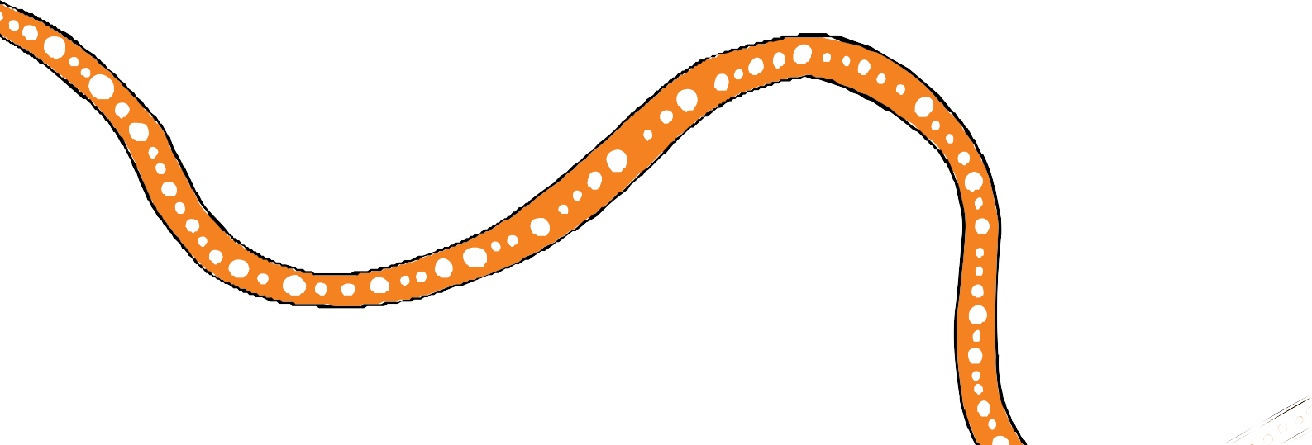

**Empowerment**

## Definition

Empowerment refers to children and young people having and being able to exercise their agency in the communities and environments in which they live, learn and work. This includes recognition of their unique place as First Nations Australians, the freedom to express themselves, advocate for the things that are important to them and participate in civil society, access to opportunity, freedom from systemic barriers, access to quality services and thrive in the early years of life.

## Why Empowerment is important



*“Empowerment means control over decisions that make you feel healthy and equipped for the future.”*

Community consultation participant, Brisbane

Empowerment is important for the wellbeing of Aboriginal and Torres Strait Islander children and young people because it is only through empowered advocacy that the lives of Aboriginal and Torres Strait Islander Queenslanders will be improved. An empowered person is confident, advocates for and can control their own future. It means the individual has choices for their life.

The Queensland *Human Rights Act 2019* (s 15, 20, 21, 22) states that a person has a right to recognition and equality before the law, the right to freedom of thought, conscience, religion and belief, freedom of expression including: the right to find, receive and share information and ideas and peaceful assembly and freedom of association.

## Outcome

Our children are heard.

16

## Indicators

* Levels of access to opportunity: education, employment, training throughout all stages of life
* Level of child and youth engagement for developing laws, policies and programs
* Level of youth voter participation
* Youth perceptions of ability to have a say
* Use and engagement of technology and social media
* Membership of social, community, or civic groups
* Level of life satisfaction
* Social and emotional development in the early years (2 to 6 years)
* Treaty making

The above indicators are indicative only and have been informed by similar indicators contained within the Better Life Index31, New Zealand’s Child and Youth Strategy32, and the National Plan for Child and Youth Wellbeing.33

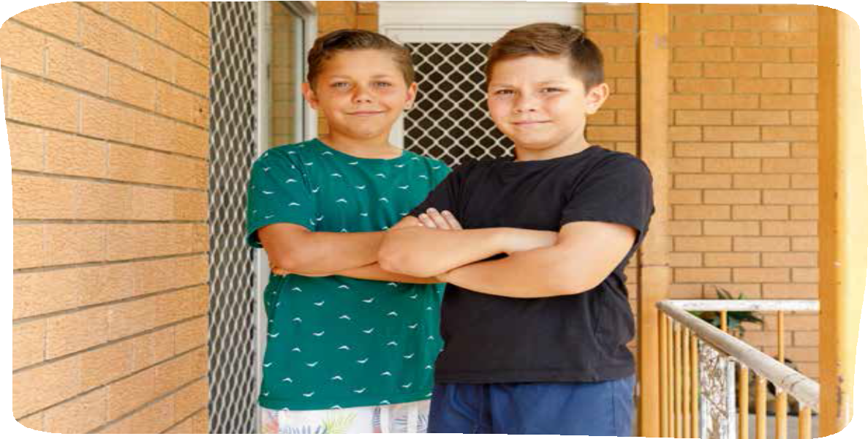

17



**Safety**

## Definition

Safety refers to children and young people growing up in a loving and supportive environment where they are free from all forms of harm and abuse. Safety includes child protection, youth justice, positive relationships, positive parenting, trauma management, and a supportive network of friends, family and community in the context of a stable and predictable environment.

## Why Safety is important



*“Being safe is about being relaxed, not have to worry… not in the constant state of fight or flight.”*

Community consultation participant, Ipswich

Safety is important for the wellbeing of Aboriginal and Torres Strait Islander children and young people because of the extent to which First Nation Australians’ children and young people are overrepresented in the child protection, youth justice and criminal justice systems. Safety is also important for fostering a sense of hope for the future that is critical for children and young people to be able to dream and fulfil their full potential.

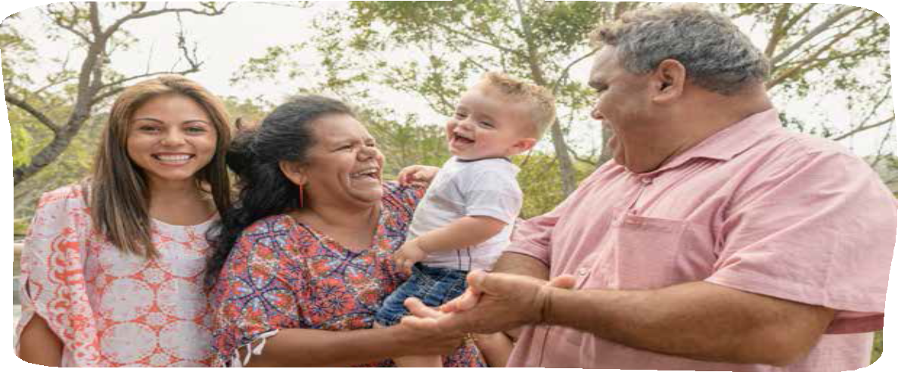

18



The Queensland *Human Rights Act 2019* (s 16, 17, 21, 29, 31, 32, 33) states that a person has right to life, right to protection from torture and cruel, inhuman or degrading treatment, a right to freedom of expression, liberty and security of person, fair hearing, rights in criminal proceedings and the rights of children in criminal proceedings.

## Outcome

Our children are safe.

## Indicators

* Representation in child protection
* Representation in youth justice
* Representation in criminal justice
* Rates of serious crimes against the person (e.g. homicide/family violence)
* Perceptions of safety (e.g. feeling safe alone at night)
* For those in the child protection system: Frequency and nature of interactions with family members and kin
* Reports of bullying
* Nature and extent of relationships with peers, siblings, adults (including parents/carers, teachers)

The above indicators have been informed by similar indicators contained within the Better Life Index34, New Zealand’s Child and Youth Strategy35, the Closing the Gap targets36, and

the National Plan for Child and Youth Wellbeing.37

19

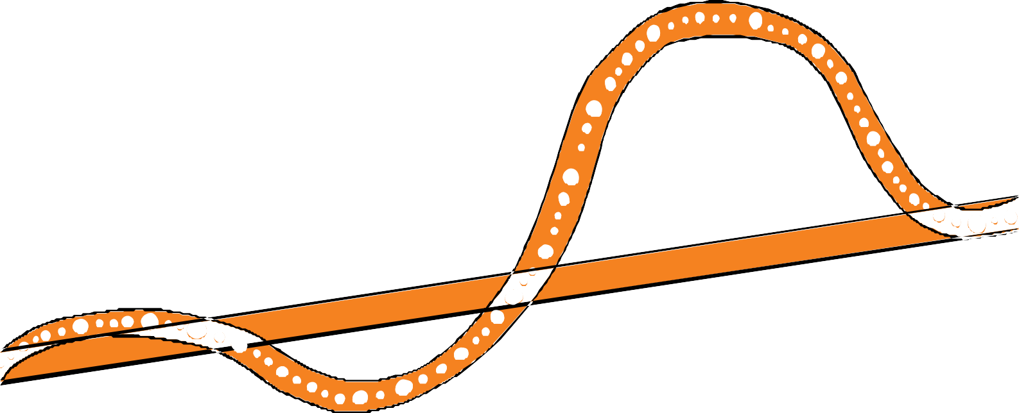

**References**

1. https:/[/www.ou](http://www.ourfuture.qld.gov.au/)r[future.qld.gov.au/,](http://www.ourfuture.qld.gov.au/) date accessed 1 August 2019.
2. https:/[/www.communities.qld.go](http://www.communities.qld.gov.au/resources/campaign/supporting-families/our-way.pdf)v[.au/resources/campaign/supporting-families/our-way.pdf,](http://www.communities.qld.gov.au/resources/campaign/supporting-families/our-way.pdf) date accessed 1 September 2019.
3. Changing Tracks: An action plan for Aboriginal and Torres Strait Islander children and families 2017-19, https:/[/www.csyw.qld.go](http://www.csyw.qld.gov.au/resources/campaign/supporting-families/changing-tracks.pdf)v[.au/resources/campaign/supporting-families/changing-tracks.pdf,](http://www.csyw.qld.gov.au/resources/campaign/supporting-families/changing-tracks.pdf) date accessed 1 September 2019.
4. Australian Institute of Health and Welfare 2017. Australia’s welfare 2017. Australia’s welfare series no. 13. AUS 214. Canberra: AIHW.
5. Ibid.
6. Ibid.
7. Department of Health. National Aboriginal and Torres Strait Islander Health Plan 2013-2023. Commonwealth of Australia. 2013. Page 9. https:/[/www.health.go](http://www.health.gov.au/internet/main/publishing.nsf/content/B92E980680)v[.au/internet/main/publishing.nsf/content/B92E980680](http://www.health.gov.au/internet/main/publishing.nsf/content/B92E980680) 486C3BCA257BF0001BAF01/$File/health-plan.pdf, date accessed 19 July 2019.
8. Department of the Prime Minister and Cabinet. Aboriginal and Torres Strait Islander Health Performance Framework: 2014 Report. Australian Government. https:/[/www.pmc.go](http://www.pmc.gov.au/sites/default/files/publications/)v[.au/sites/default/files/publications/](http://www.pmc.gov.au/sites/default/files/publications/) indigenous/Health-Performance-Framework-2014/tier-1-health-status-and-outcomes/118-social-and- emotional-wellbeing.html, date accessed 1 August 2019.
9. https:/[/www.legi](http://www.legislation.qld.gov.au/view/whole/html/asmade/act-2019-005)s[lation.qld.gov.au/view/whole/html/asmade/act-2019-005,](http://www.legislation.qld.gov.au/view/whole/html/asmade/act-2019-005) date accessed 1 October 2019.
10. https:/[/www.ohchr.org/en/prof](http://www.ohchr.org/en/professionalinterest/pages/crc.aspx)e[ssionalinterest/pages/crc.aspx,](http://www.ohchr.org/en/professionalinterest/pages/crc.aspx) date accessed 10 August 2019.
11. https://undocs.org/A/RES/61/295, date accessed 10 August 2019.
12. https://childyouthwellbeing.govt.nz/, date accessed 1 October 2019.
13. https:/[/www.pmc.go](http://www.pmc.gov.au/sites/default/files/reports/closing-the-gap-2018/executive-summary.html)v[.au/sites/default/files/reports/closing-the-gap-2018/executive-summary.html,](http://www.pmc.gov.au/sites/default/files/reports/closing-the-gap-2018/executive-summary.html) date accessed 1 September 2019.
14. Australian Research Alliance for Children and Youth, https:/[/www.aracy.org.au/projects/the-ne](http://www.aracy.org.au/projects/the-nest)s[t,](http://www.aracy.org.au/projects/the-nest) date accessed 1 September 2019.
15. OECD, [http://www.oecdbetterlifeindex.org,](http://www.oecdbetterlifeindex.org/) date accessed 1 September 2019.
16. https:/[/www.pmc.go](http://www.pmc.gov.au/sites/default/files/reports/closing-the-gap-2018/executive-summary.html)v[.au/sites/default/files/reports/closing-the-gap-2018/executive-summary.html,](http://www.pmc.gov.au/sites/default/files/reports/closing-the-gap-2018/executive-summary.html) date accessed 1 September 2019.
17. Australian Research Alliance for Children and Youth, https:/[/www.aracy.org.au/projects/the-ne](http://www.aracy.org.au/projects/the-nest)s[t,](http://www.aracy.org.au/projects/the-nest) date accessed 1 September 2019.
18. OECD, [http://www.oecdbetterlifeindex.org,](http://www.oecdbetterlifeindex.org/) date accessed 1 September 2019.
19. https://childyouthwellbeing.govt.nz/ date accessed 1 October 2019.
20. https://www.pmc. gov.au/sites/default/files/reports/closing-the-gap-2018/executive-summary. html, date accessed 1 September 2019.
21. Australian Research Alliance for Children and Youth, https:/[/www.aracy.org.au/projects/the-ne](http://www.aracy.org.au/projects/the-nest)s[t,](http://www.aracy.org.au/projects/the-nest) date accessed 1 September 2019.
22. OECD, [http://www.oecdbetterlifeindex.org,](http://www.oecdbetterlifeindex.org/) date accessed 1 September 2019.
23. https://childyouthwellbeing.govt.nz/, date accessed 1 October 2019.
24. https:/[/www.pmc.go](http://www.pmc.gov.au/sites/default/files/reports/closing-the-gap-2018/executive-summary.html)v[.au/sites/default/files/reports/closing-the-gap-2018/executive-summary.html,](http://www.pmc.gov.au/sites/default/files/reports/closing-the-gap-2018/executive-summary.html) date accessed 1 September 2019.
25. Australian Research Alliance for Children and Youth, https:/[/www.aracy.org.au/projects/the-ne](http://www.aracy.org.au/projects/the-nest)s[t,](http://www.aracy.org.au/projects/the-nest) date accessed 1 September 2019.
26. OECD, [http://www.oecdbetterlifeindex.org,](http://www.oecdbetterlifeindex.org/) date accessed 1 September 2019.
27. https://childyouthwellbeing.govt.nz/, date accessed 1 October 2019.

20

1. https:/[/www.pmc.go](http://www.pmc.gov.au/sites/default/files/reports/closing-the-gap-2018/executive-summary.html)v[.au/sites/default/files/reports/closing-the-gap-2018/executive-summary.html,](http://www.pmc.gov.au/sites/default/files/reports/closing-the-gap-2018/executive-summary.html) date accessed 1 September 2019.
2. OECD, [http://www.oecdbetterlifeindex.org,](http://www.oecdbetterlifeindex.org/) date accessed 1 September 2019.
3. https://childyouthwellbeing.govt.nz/, date accessed 1 October 2019.
4. Australian Research Alliance for Children and Youth, https:/[/www.aracy.org.au/projects/the-ne](http://www.aracy.org.au/projects/the-nest)s[t,](http://www.aracy.org.au/projects/the-nest) date accessed 1September 2019.
5. OECD, [http://www.oecdbetterlifeindex.org,](http://www.oecdbetterlifeindex.org/) date accessed 1 September 2019.
6. https://childyouthwellbeing.govt.nz/, date accessed 1 October 2019.
7. https:/[/www.pmc.go](http://www.pmc.gov.au/sites/default/files/reports/closing-the-gap-2018/executive-summary.html)v[.au/sites/default/files/reports/closing-the-gap-2018/executive-summary.html,](http://www.pmc.gov.au/sites/default/files/reports/closing-the-gap-2018/executive-summary.html) date accessed 1 September 2019.
8. Australian Research Alliance for Children and Youth, https:/[/www.aracy.org.au/projects/](http://www.aracy.org.au/projects/) the-nest, date accessed 1 September 2019.

21

0722-NOV2019

